Injury & Illness
Prevention Program
(IIPP) Manual

School of Dentistry

Updated August 2020

THIS PAGE INTENTIONALLY LEFT BLANK.

Injury & Illness Prevention Program

School of Dentistry

Updated August 2020

Office of Environment, Health and Safety

THIS PAGE INTENTIONALLY LEFT BLANK.

Table of Contents

IIPP Information v
Section 1: Introduction and Scope 1-1
Section 2: Responsibilities 2-1
Section 3: Identification and Evaluation of Workplace Hazards 3-1
Section 4: Correcting Workplace Hazards 4-1
Section 5: Communicating Workplace Hazards 5-1
Section 6: Incident, Injury & Illness Reporting and Investigations 6-1
Section 7: Training and Documentation 7-1
Section 8: Compliance 8-1
Appendix A: Forms and Checklists 1
Appendix B: Training Guides 1
Appendix C: Resources C-1
Appendix D: Departmental Training Records D-1

THIS PAGE INTENTIONALLY LEFT BLANK.

IIPP Information

Effective Date | Jul 2013; Rev. Jul 2014, Rev. Sep 2015; Rev. Dec 2016; Rev. Jul 2018; Rev Jun 2020; Rev. Aug 2020
Department | School of Dentistry
Department Head | Paul Krebsbach
 | Name
 | Dean, School of Dentistry
 | Title
Safety Coordinator(s) or liaison(s) | Surui Zhang
 | Name
 | szhang@dentistry.ucla.edu
 | E-mail
Safety Related Items | Dean’s Suite, CHS 53-038
 | Location of safety meeting minutes
 | Den’s Suite, CHS 53-038
 | Location of “Employee Safety Recommendation” forms
 | Dean’s Suite, CHS 53-038
 | Location of training and other safety-related items
 | Clinic Unit Supervisors
 | Person who assists injured employees with appropriate paperwork

The Safety Committee Meets |  | Quarterly
 |  | (Quarterly meetings required)
The Safety Committee members are:
Chair’s Name | Dr. Fariba Younai
Section/Sub-unit | Division of Oral Biology
Member Name | Dr. Shen Hu
Section/Sub-unit | Division of Oral Biology
Member Name | Dr. Paulo M. Camargo
Section/Sub-unit | Associate Dean of Clinical Affairs
Member Name | Dr. Ki-Hyuk Shin
Section/Sub-unit | Division of Oral Biology
Member Name | Vina Chin
Section/Sub-unit | Assistant Dean of Administration and External Relations
Member Name | Lisa Gotori-Koga
Section/Sub-unit | School of Dentistry Facilities Supervisor
Member Name | Surui Zhang
Section/Sub-unit | School of Dentistry EH&S Specialist
Member Name | Scott Hsieh
Section/Sub-unit | Campus EHS Specialist

Buildings occupied by this department: This section will assist you in ensuring that all your staff members are trained on the appropriate Emergency Response and Business Continuity Plans. (For off campus buildings, write the physical address of the building. Do not include buildings used only for storage.)

 | 1. Building name or address |  | CHS, 10833 Le Conte Ave, Los Angeles, CA 90095
 | Unit within your department (if applicable) |  | See attached floor plans
 | Building Contact and phone # |  | Lisa Gotori-Koga, 310-825-7141
 | 2. Building name or address |  | 100 UCLA Med Plaza
 | Unit within your department (if applicable) |  | Faculty Group Dental Practice Suite
 | Building Contact and phone # |  | Susie Manrique, 310-206-7321
 | 3. Building name or address |  | 323 Lincoln Blvd.
 | Unit within your department (if applicable) |  | Venice Dental Center
 | Building Contact and phone # |  | Debra Thomas, 310-392-4103

Introduction and Scope

The UCLA Injury and Illness Prevention Program (IIPP) is a guide to assist university administrators and supervisors to promote the health and safety of their employees. This IIPP complies with the Cal/OSHA requirement to provide a safe and healthful workplace for all employees (California Code of Regulations Title 8, Section 3203). It establishes methods for identifying and correcting workplace hazards, providing employee safety training, communicating safety information, and ensuring compliance with safety programs. It is reviewed and updated annually to reflect any changes in regulations, personnel or procedures.

THIS PAGE INTENTIONALLY LEFT BLANK.

Responsibilities

Executive Management
The department AVC/Chair/Dean/Director must ensure that a department-specific IIPP is implemented in areas that fall under their control. They are responsible for the following:
- Communicating management’s commitment to health and safety to their employees;
- Ensuring that areas under their control comply with internal and external regulations and guidelines;
- Providing individuals under their management with the authority and resources to develop and implement appropriate health and safety programs, practices and procedures;
- Designating a Department Safety Coordinator; and
- Establishing a departmental process (such as a safety committee) to maintain and update the departmental IIPP, assess departmental compliance with applicable regulations and campus policies, evaluate reports of unsafe conditions, and coordinate any necessary corrective actions.

Principal Investigators/Supervisors/Managers
Supervisors play a key role in the implementation of the departmental IIPP. They are responsible for the following:
- Encouraging a safe work culture by communicating UCLA’s emphasis on health and safety to their staff;
- Modeling and enforcing safe and healthy work practices;
- Ensuring that employees are properly trained to complete all assigned tasks;
- Ensuring periodic inspection of workspaces under their authority;
- Stopping work that poses an imminent hazard to any employee;
- Implementing measures to eliminate or control workplace hazards;
- Developing safe work procedures such as Standard Operating Procedures (SOP) and Job Safety Analyses (JSA);
- Providing appropriate safety training and personal protective equipment to employees under their supervision;
- Reporting and investigating work related injuries and illnesses;
- Encouraging employees to report health and safety issues without fear of reprisal;
- Disciplining employees that do not comply with safe work practices; and
- Documenting employee training and departmental safety activities.

Employees
All employees must comply with all applicable health and safety regulations, policies, and work practices. This includes, but is not limited to the following:
- Using personal protective equipment (where required);
- Actively participating in all required safety and health training;
- Learning about the potential hazards of assigned tasks and work areas;
- Complying with health and safety-related signs, posters, warnings and directions;
- Requesting information related to job safety whenever needed;
- Reporting all work-related injuries and illnesses promptly to their supervisor;
- Warning co-workers about defective equipment and other hazards;
- Reporting any unsafe or unhealthy conditions immediately to a supervisor, and stopping work if it poses an imminent hazard;
- Cooperating with incident investigations to determine the root cause; and
- Participating in workplace safety inspections.

Department Safety Coordinator or Safety Liaison
The Department Safety Coordinator or safety liaison monitors the safety activities within the department and serves as the departmental liaison with EH&S. The Department Safety Coordinator is responsible for the following:
- Obtaining relevant information regarding safety and health regulations, procedures, and safeguards affecting employees within their control;
- Planning and coordinating routine safety meetings (if department has opted to create a Safety Committee);
- Investigating accidents and incidents to identify and implement any corrective actions necessary to prevent future incidents;
- Ensuring that regular health and safety inspections are conducted within their area of responsibility;
- Reporting to EH&S any unsafe or unhealthy conditions, which they cannot correct; and
- Maintaining department safety records to document employee training, inspections, safety meetings and incident investigations.

Department Safety Committees
Department based safety committees are important for a successful campus-wide program. While not mandated, implementation of departmental safety committees is highly recommended. Departmental Safety Committees work under the direction of the Department Safety Coordinator or safety liaison and are responsible for the following:
- Developing, implementing and maintaining the departmental IIPP;
- Assessing departmental compliance with applicable regulations and campus policies;
- Reviewing workplace inspections to identify any needed corrections;
- Reviewing reports of unsafe conditions that cannot be immediately corrected by an employee or supervisor, and coordinating any necessary corrective action;
- Conducting hazard and incident investigations to assist in establishing corrective actions;
- Tracking of correction of workplace hazards;
- Reviewing all departmental incident and injury investigations to ensure that all causes have been identified and corrected;
- Developing suggestions for employee training based on reviews of incidents/injuries;
- Reviewing employee safety suggestions and submitting recommendations for corrections to department management; and
- Preparing written meeting minutes using the IIPP Form “Departmental Safety Committee Meeting Minutes” (See Appendix A) or a similar form.
The Departmental Safety Committee should meet at least quarterly and have representatives for each employee within the department. Membership may rotate periodically.

Environment, Health & Safety (EH&S) Injury Prevention Division
The EH&S Injury Prevention Division (IPD) provides consultation and support to Department Safety Coordinators and Safety Committees. IPD safety specialists provide support and training to promote a campus-wide safety program. Support activities include, but are not limited to the following:
- Materials for departmental safety meetings and safety initiatives;
- Assistance with inspections and incident investigations; and
- Assistance with development, implementation and maintenance of departmental IIPPs.

Director of Environment, Health and Safety
The Director of Environment, Health, and Safety (EH&S) has authority and responsibility for overall implementation and maintenance of the IIPP. Specific responsibilities include the following:
- Interpreting external regulations to develop appropriate compliance strategies;
- Reviewing methods and procedures to correct unsafe and/or unhealthy conditions;
- Ensuring that there are procedures to communicate UCLA’s safety and health policies and guidelines to employees; and
- Monitoring the effectiveness of the overall IIPP and making improvements as needed.
THIS PAGE INTENTIONALLY LEFT BLANK.

Identification and Evaluation of Workplace Hazards

Inspection Program Overview
Safety inspections identify and evaluate workplace hazards and conditions that could result in illness, injury or property damage. Managers and supervisors must ensure that safety inspections are conducted on a regular basis. Inspections must also be completed when management is made aware of existing or new hazards in the workplace.
The Departmental Safety Coordinator or designated safety liaison is responsible for identifying workplace hazards. These individuals are responsible for ensuring that periodic inspections are completed to assess, record, and correct hazardous and potentially hazardous conditions that may exist. The inspections may be conducted by the Department Safety Coordinator, Safety Committee, supervisors or other assigned personnel.

Scheduled Safety Inspections
All administrative departments, shops and laboratories must complete workplace safety inspections. By law, the first of these inspections must take place when the department first adopts a department specific IIPP. Inspections are documented and reviewed by management, the Department Safety Coordinator, and/or the Department Safety Committee. Ongoing inspections will take place as indicated below:
OFFICES – Annual inspections of all office areas will be completed to detect and eliminate any hazardous conditions that exist. The Office Inspection Checklist (See Appendix A), or similar form, can be used to complete inspections. The Computer Workstation Checklist (See Appendix A) is also available to evaluate computer workstations. Computer workstation evaluations can also be completed using the BruinErgo Office Ergonomics & Risk Management Solutions on-line program, or by contacting the EH&S Ergonomics Division for assistance.
CHEMICAL LABORATORIES – Annual inspections of all laboratories are required (semi-annual inspections suggested as best practices) to detect and eliminate any existing hazardous conditions using the Laboratory Inspection Checklist (See Appendix A) or similar form. One of these inspections will be completed by the Chemical Hygiene Officer or an EH&S Laboratory Inspector; the second inspection can be completed by the Laboratory Manager, Principal Investigator (PI), Safety Coordinator or designee.
SCHOOL OF DENTISTRY LABORATORIES - In-house annual inspections of all laboratories will be required 6 months prior to EH&S annual inspections. These inspections will be completed by a designated individual. These inspections will be required to detect and eliminate any existing hazardous conditions using the Laboratory Inspection Checklist, or similar form (See Appendix A).
BIOSAFETY LEVEL (BSL) 1, 2/2+, Biological Toxins / ANIMAL BSL (ABSL) LABORATORIES – Inspections of BSL/ABSL Laboratories are required every three years to detect and reduce/eliminate any existing hazardous conditions using the appropriate BSL Laboratory Inspection (See Appendix A). These inspections are to be conducted by the EH&S Biosafety Officer (BSO) or an
RADIATION/LASERS – Facilities that use radioactive material, radiation producing machines and/or lasers require inspections by EH&S Radiation Safety. Inspections are to be conducted for these hazards routinely (once or twice per year as best practice) by the Laboratory Manager, Principal Investigator (PI), Safety Coordinator or designee in addition to those conducted by EH&S.

Unscheduled Safety Inspections
Unscheduled safety inspections will be completed whenever new substances, processes, procedures, or equipment are introduced into the workplace and present new safety or health hazards. Additional inspections will be completed whenever management is informed of previously unrecognized hazards.

Reporting Hazards or Unsafe Work Practices
Employees are encouraged to report existing or potentially hazardous conditions or unsafe work practices to their supervisor so that necessary action (including training, purchase of appropriate equipment, etc.) can be taken in a timely manner. The Hazard Notification/Safety Recommendation Form (See Appendix A) or similar form can be used to report unsafe conditions.
Supervisors, the Safety Coordinator or liaison, or members of safety committees should complete the Hazard Notification/Safety Recommendation Form when made aware of an unsafe condition for which an immediate remedy cannot be implemented. The form can be used to document controls implemented to reduce or eliminate any unsafe conditions. Corrective actions shall be identified and completed by the department, and the form shall be filed internally for documentation purposes.
For additional assistance with the Hazard Notification/Safety Recommendation Form and/or identification of the appropriate corrective actions, please contact EH&S Injury Prevention Division at injuryprevention@ehs.ucla.edu. Employees who report such conditions cannot be disciplined or suffer any reprisals. Complaints can be made anonymously.

Correcting Workplace Hazards

Hazard Correction
Hazard levels range from being imminently dangerous to relatively low risk. Corrective actions or plans, including suitable timetables for completion, are the responsibility of the department. EH&S consultation is available to determine appropriate abatement actions.

Corrective actions or plans must be appropriate for the severity of the hazard. If an imminent hazard exists, work in the area should cease, and the appropriate supervisor be contacted. If the hazard cannot be immediately corrected without endangering employees or property, evacuate all unnecessary personnel from the area. Individuals entering the hazard area to correct the condition must have protective equipment and other necessary safeguards before addressing the situation.

Specific procedures that can be used to correct hazards include, but are not limited to, the following:

- Stopping unsafe work practices and providing retraining on proper procedures before work resumes;
- Reinforcing use of and providing personal protective equipment;
- Lock-out/tag-out of unsafe equipment;
- Isolating or barricading areas that have chemical spills or other hazards to deny access until appropriate correction is made; and
- Reporting problems or hazardous conditions to a supervisor, EH&S Hotline at 310-825-9797, or Facilities Trouble Call Desk at 310-825-9236.
Supervisors can seek assistance in developing appropriate corrective actions by submitting a Hazard Notification/Safety Recommendation Form (See Appendix A) to their Department Safety Committee, Safety Coordinator or liaison, or EH&S.

Hazard Correction Report
The Hazard Identification/Correction Form (See Appendix A) or similar form, must be used to document corrective actions, including projected and actual completion dates. This form can be attached to safety meeting minutes to document hazard correction activities completed by the department.

THIS PAGE INTENTIONALLY LEFT BLANK.

Communicating Workplace Hazards

Supervisors
Supervisors are responsible for communicating safety and health issues in a form readily understandable by all workers. All department personnel are encouraged to communicate safety concerns to their supervisor without fear of reprisal.

Safety Committee
The Departmental Safety Committee serves as the primary resource for communicating health and safety issues to department employees. Each employee is represented by a member of the safety committee. This representative is responsible for communicating information concerning hazard identification and correction. Safety Committee minutes are posted or available at a convenient location in the department.
The Safety Committee can also sponsor seminars or speakers, or coordinate other means to communicate with employees regarding health and safety matters.

Resources
While supervisors have primary responsibility for providing employees with hazard information pertinent to their work assignments, information concerning safety hazards is available from a number of other sources. Safety information is communicated to employees by e-mail, voice mail, distribution of written memoranda, or by articles in internal departmental newsletters (if applicable). Examples can be found in Appendix C: Resources. Other resources include, but are not limited to the following examples.

EH&S Website
The EH&S website has extensive health and safety information and resources for employees. Health and safety specialists can be contacted through the website to answer inquiries and provide assistance to employees. Visit the EH&S website for more information.

Safety Bulletin Boards
EH&S maintains safety information and regulatory requirements on safety bulletin boards located throughout campus. Postings include emergency contact information, worker’s compensation postings, Cal/OSHA announcements and updates. Visit the Cal/OSHA website for more information.

Safety Data Sheets
Safety Data Sheets (SDS) provide information on the potential hazards of products or chemicals. Hard copies of SDS for the chemicals should be available to all employees in a convenient location. SDS fact sheets, hazard communication videos, and other training materials are available from the manufacturer and/or EH&S. Visit the UC SDS website for more information.

Standard Operating Procedure (SOP) or Job Safety Analysis (JSA)
The purpose of an SOP or JSA is to recognize hazards associated with the operation of a piece of equipment or task and determine how to control those hazards. SOPs or JSAs are available for tasks and equipment that present hazards to employees. Components of the JSA include:

- Picture of equipment or task
- Tasks associated with use of equipment or job that have hazards
- Risks associated with tasks
- Solutions to reduce risk
- Recommended PPE

Refer to Appendix A and the EH&S JSA Library for examples.

Equipment Operating Manuals
All equipment must be operated in accordance with the manufacturer’s instructions as specified in the equipment’s operating manual. Copies of operating manuals are kept with each piece of equipment used in the department. Employees are required to review and demonstrate understanding of the SOP/JSA or the operating manual before using the equipment.

EXPOSURE SPECIFIC PROGRAMS
EH&S has supplemental written programs that address specific exposures in addition to the IIPP, including Confined Space Program, Exposure Control Plans for Bloodborne Pathogens and Aerosol Transmissible Diseases, Fall Protection Program, Hazard Communication Program, UCLA Heat Illness Prevention Plan and UCLA Lock Out Tag Out (LOTO) Program.

Safety Manuals
EH&S has area and job-specific safety manuals in addition to the IIPP, including the Biohazard Safety Manual, Chemical Hygiene Plan/Laboratory Safety Manual, Laser Safety Manual, Radiation Safety Manual, and Shop Safety Manual. These manuals provide general guidelines for these jobs and areas and are available at the EH&S website www.ehs.ucla.edu.

EMERGENCY ACTION PLAN

The UCLA Emergency Action Plan addresses life and safety issues that emerge as a result of a disaster, emergency, catastrophic event or crisis (e.g., earthquake, fire, flood, loss of critical infrastructure, terrorist attack, civil unrest, etc.). The EH&S Office of Emergency Management provides campus building personnel with an Emergency Action Plan template, which incorporates the critical elements necessary for area specific plans for each building. The Office of Emergency Management also provides Facility, Floor and Area Warden training and consultations on the Emergency Action Plan. Visit the UCLA Office of Emergency Management website or email uclaoem@ehs.ucla.edu for more information.

Business Continuity Plan
A Business Continuity Plan is used to help you to continue your operations once life and safety have been secured. Although the two plans work hand in hand, the Business Continuity Plan is different from an Emergency Action Plan in that the former describes a departmental plan of action that can be taken to lessen the impact of disruptions, while the latter describes how to prepare and respond to these disruptions. The Office of Insurance and Risk management assists campus departments with developing a Business Continuity Plan using the “UC Ready” software tool. Visit the IRM Business Continuity website for more information.

THIS PAGE INTENTIONALLY LEFT BLANK.

Incident, Injury & Illness Reporting and Investigations

Introduction
An incident is an unplanned event which results in an accident, injury, illness or property damage. A near miss is an unplanned event that did not result in an accident, injury, illness, or damage, but had the potential to do so. Both incidents and near misses are reported and investigated to implement procedures to reduce the likelihood of future reoccurrence.

Incident, Injury and Illness Reporting and Treatment
Employees who are injured or become ill at work must report the injury or illness immediately to their supervisor and personnel department. The supervisor/department must provide employees with the level of medical attention required for the situation.

Medical Treatment
For non-emergency medical treatment of work-related injuries or illnesses, employees should be sent to the Occupational Health Facility (OHF) during normal business hours, or the Emergency Department (ED) at the Ronald Reagan/UCLA Medical Center (RRMC) after normal work hours.

If immediate medical treatment beyond first aid is required, call 911 from a campus phone, or contact UCPD dispatch at 310-825-1491 from off-campus or cell phones. If working at a site other than the main UCLA campus, use the nearest designated medical facility for your organization.

Forms
Supervisors must complete and provide injured employees with the UCLA Incident Report & Referral for Medical Treatment form to take to the treating facility. If the injury is more than first aid treatment, also provide the employee with a “Workers’ Compensation Claims Form (DWC-1) & Notice of Potential Eligibility” form. Refer to Appendix A for the necessary forms.

Reporting
All injuries must be reported to Insurance and Risk Management (IRM) within 24 hours. Injuries can be reported to IRM using the Incident Report and Referral for Medical Treatment and DWC-1 Claim Forms, or through Electronic First Report at https://ehs.ucop.edu/efr. Injuries that meet the Cal/OSHA definition of “Serious Injury” must be immediately reported to the EH&S Hotline at 310-825-9797. Refer to Appendix A for reporting specifics.

EMPLOYEE INJURIES/ILLNESSES OCCURRING AT OFF-SITE LOCATIONS

Employees working off-site must report any injury or illness to their immediate supervisor and the Departmental Injury Reporting Liaison (on the UCLA campus) within 8 hours of the incident or sooner if at all possible. If the initial report of the incident is made by phone, a follow up email shall be sent specifying the date, time and details about the injury or illness.
The highest level supervisor traveling with the cohort of field workers to any off-site event or venue is responsible for making sure that the appropriate telephone numbers (including the campus telephone number of the Departmental Injury Reporting Liaison) are programmed into the traveling employee’s phone.

Serious Injuries
Serious occupational injuries, illnesses or exposures to hazardous substances, as defined by Cal/OSHA, must be reported to EH&S immediately when they become known to managers or supervisors. Serious injuries include deaths, amputations, concussions, crush injuries, fractures, burns, lacerations with significant bleeding or requiring stitches, or hospitalization (other than for observation) for greater than 24 hours. Supervisors must report injuries that meet the Cal/OSHA definition of Serious Injury to the EH&S Hotline at 310-825-9797 as soon as they are notified of the injury. Required information includes the name of the injured employee, a brief summary of the incident, description of the injuries obtained by the employee, and a number where the reporting supervisor can be reached. EH&S must report the injury to Cal/OSHA within eight hours of occurrence. Departments are responsible for a minimum payment of a $5000 fine for late reporting. EH&S will conduct an incident investigation with a representative from the injured employee’s department to determine any contributing conditions and develop corrective action plans.

Incident Investigations
Incident Investigations are conducted to determine and correct for any safety hazards that may result or have resulted in injury or illness. Specific procedures that can be used to investigate workplace incidents and hazardous substance exposures include:

- Interviewing injured personnel and witnesses;
- Examining the injured employee’s workstation for causative factors;
- Reviewing established procedures to ensure they are adequate and were followed;
- Reviewing training records of affected employees;
- Determining all contributing causes to the incident;
- Taking corrective actions to prevent the incident/exposure from reoccurring; and
- Recording all findings and corrective actions taken.

Findings and corrective actions must be documented using the Incident Investigation form (See Appendix A) or similar form.

The employee’s supervisor or departmental designee must review the investigation report to ensure that the investigation was thorough and that all corrective actions are completed. Investigations and/or corrective actions that are found to be incomplete should be routed back to the investigator for further follow-up. All corrective actions that are not implemented in a reasonable period of time must be discussed with the department manager. EH&S safety specialists are available to help resolve outstanding issues and problems.

THIS PAGE INTENTIONALLY LEFT BLANK.

Training and Documentation
Effective dissemination of safety information is essential for a successful IIPP. All employees must be trained in general safe work practices, including specific instructions on hazards unique to their job assignment. Minimal training requirements include safe use of workplace equipment, manual materials handling, identifying hazards in work area, use of personal protective equipment, safe handling of hazardous materials, and proper procedures for disposal of hazardous waste. Training must be completed before use of any dangerous equipment, exposure to any known hazardous conditions, or when new hazards are identified.
Managers must ensure supervisors are trained to recognize and abate safety and health hazards to which their employees are exposed. Supervisors are responsible for ensuring their employees receive appropriate safety training and for documenting that this training has been provided. Attendance at training classes and safety meetings is required. Documentation of individual safety training and safety meetings must be kept by the Department Safety Coordinator or safety liaison, and site-specific trainings for high hazard areas must be kept by the manager in that area.

Safety Training
Cal/OSHA mandates that all employees participate in periodic safety trainings during which topics relevant to the workplace are reviewed and discussed. Safety training meetings can include status reports on safety inspections, hazard mitigation projects, incident investigation results, and employee safety suggestions. Safety trainings can be incorporated into staff meetings, presented during “tailgate” meetings, done electronically, or conducted via one-on-one coaching. The duration of safety meetings can vary based on the subject and training format.
As best practices, all employees should complete training in the following areas:
- Illness and Injury Prevention Program;
- Fire Safety;
- Emergency Preparedness/Earthquake Safety;
- Safety Lifting/Back Injury Prevention;
- Hazard Communication & Awareness (Use of SDS);
- General Safety and Housekeeping;
- Specific hazard instruction unique to the job assignment such as hazardous waste, blood borne pathogens, power tool safety, laser safety, radiation safety, etc.;
- Hazard instruction related to introduction of new substances, processes, procedures or equipment introduced to the workplace; and
- Hazard instruction of new or previously unrecognized hazards.
Refer to Cal/OSHA Training and Instruction Requirements for more information on mandated safety trainings. Additional assistance with training needs can be obtained by contacting training@ehs.ucla.edu or logging on to worksafe.ucla.edu.

Documentation
Cal/OSHA regulations require that records for occupational injuries and illnesses, medical surveillance, exposure monitoring, inspections, training, and other safety activities be maintained for specific periods of time. Records must be kept in employee personnel files following University guidelines. Department personnel representatives must present them to Cal/OSHA or other regulatory agency representatives if requested. EH&S may review these records during routine compliance inspections.

Safety Training
Employee training must be provided at no cost to the employee during the employee’s normal working hours. Safety training may be provided by a knowledgeable supervisor or department member, or by representatives from other relevant campus departments and approved vendors. Online training for select topics is provided at worksafe.ucla.edu. All safety training must be documented using the Training Documentation Form (See Appendix D) or similar form, which includes all the following:

- Date of training;
- Name of trainer;
- Topic;
- Name, department, ID number, and signature of each attendee; and
- Outline of safety topic (may be attached).

Safety Inspection Reports
The Department Safety Coordinator or safety liaison, human resources specialist, or area supervisor is responsible for maintaining safety inspection records and reports. Inspection reports are to be kept in Appendix D or electronically. The record must include the following:

- Name of inspector;
- Date of inspection;
- Any identified unsafe or unhealthy condition or work practice; and
- Corrective action(s) to remedy the identified hazard(s).

Recordkeeping
The following records must be kept on file in the department for the minimum times indicated below:
- Safety inspection forms = 5 years;
- Hazard identification forms = 5 years;
- Incident investigations = 5 years;
- Safety postings and safety meeting agendas = 5 years;
- Safety training checklists and related training documents = Duration of each individual’s employment; and
Exposure records, or other employee medical records = 30 years or for the duration of each individual’s employment if > 30 years. Access to employee medical records will be limited in accordance with University policies, state and federal guidelines.

THIS PAGE INTENTIONALLY LEFT BLANK.

Compliance

Compliance is critical for an effective Injury & Illness Prevention Program. Managers and supervisors serve as role models for working safely and provide resources necessary to ensure a safe work environment for their staff. All employees are required to follow safety policies and operating procedures. Employees will be provided with safety training and information to complete all assigned duties safely. When needed, employees will be provided with additional training and information, or re-training to maintain their knowledge of campus safety policies and procedures.

Employees who demonstrate safe work practices may be rewarded through the use of performance evaluations or incentive programs. Any employee who demonstrates repeated unsafe, unhealthy work practices will be subject to corrective action and/or disciplinary action. Disciplinary action will be in conformance with UCLA policies and/or corrective bargaining agreements. If the offense is egregious or willful, the action may result in immediate disciplinary action. The Employee Labor Relations Department must be consulted on any disciplinary matter as it relates to compliance with this program.

THIS PAGE INTENTIONALLY LEFT BLANK.

Forms and Checklists

This appendix includes the following checklists, forms and safety related documents:

- How to Use a Self-Inspection Checklist
- Office Inspection Checklist
- Computer Workstation Checklist
- Hazard Notification/Safety Recommendation Form
- Departmental Safety Meeting Minutes
- Job Safety Analysis Form
- Job Safety Analysis Example
- Injury and Illness Reporting Procedures
- Serious Injury Poster
- Injury Reporting and Treatment Flow Chart
- Incident Report & Referral for Medical Treatment
- Workers’ Compensation Claim Form (DWC-1)
- Incident Investigation Form
- Guide for Completing Incident Investigations
- Disciplinary Action Guidelines
- Lab Safety Inspection Form
- Laboratory Safety Inspection Process
- Biosafety Level 1 Inspection Checklist
- Biosafety Level 2/2+ Inspection Checklist
- Biosafety Level Biological Toxins Inspection Checklist
- Animal Biosafety Level Inspection Checklist
- Radiation Safety Summary Inspection Report
- Laser Safety Inspection Checklist
- Analytical X-Ray Inspection Report

THIS PAGE INTENTIONALLY LEFT BLANK.
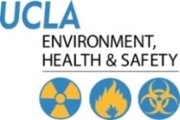 | Injury & Illness Prevention Program  How to Use a Self-Audit Inspection Checklist
 | 501 Westwood Plaza, 4th Fl • Los Angeles, CA 90095 • Ph: 310-825-5689 • Fx: 310-825-7076 • www.ehs.ucla.edu

The Office of Environmental Health and Safety (EH&S) has developed a self-audit Office Inspection Checklist to assist departments in eliminating workplace hazards. The checklist can be used by an entire department, a section of a department, a particular room or an individual to document findings from regular inspections.

The EH&S Office Inspection checklist can be modified for development of a customized checklist to meet your department’s specific needs.

The checklist is for internal departmental use. There is no need to send copies of completed checklists to EHS. If assistance from EHS is desired, please contact us at (310)825-5689.

There are a series of self-audit checklists available from EH&S for a variety of work settings. They include the following:

- Office Safety Checklist
- Computer Workstation Checklist
- Floor Inspection Checklist (Slip and Fall Prevention Program)
- Laboratory Safety Inspection Checklist
- Shop Inspection Checklist
- Biosafety Inspection Checklists
- Radiation Inspection Checklists

The checklists can be obtained from the EH&S website or your EH&S Safety Specialist. Hard copy versions of the checklists can be requested from EH&S.

Safety inspections should be completed annually by someone familiar with your workplace, tasks and jobs. Any problems found must be corrected. Assign an individual to develop a correction plan for problems and set deadline for corrections to be completed. The Hazard Identification Record Form can be used to document the correction process.

Inspections should be reviewed for trends to determine if problems are re-occurring. These problems need to be addressed at Safety meetings and corrected.

If you have any questions about the inspection checklists, contact EH&S at x55689 or injuryprevention@ehs.ucla.edu.
THIS PAGE INTENTIONALLY LEFT BLANK.
Injury & Illness Prevention Program
Office Inspection Checklist
501 Westwood Plaza, 4th Fl • Los Angeles, CA 90095 • Ph: 310-825-5689 • Fx: 310-825-7076 • www.ehs.ucla.edu

 | Yes | No | Comments
Administrative |  |  | If NO, describe what will be done to correct the hazard.
Is there a current IIPP in a location known & accessible to all employees?
Is there a safety bulletin board or equivalent displaying emergency contact information, evacuation routes, safety information, etc.?
Is there a departmental Emergency Response Plan/Emergency Action Plan in place?
Are all employees trained on all departmental protocols & procedures?
General Safety/ Housekeeping
Are stairwells & walkways kept clear from boxes & clutter?
Are stairs & handrails in good condition?
Are doorways & exits kept clear from obstacles and clutter?
Are stepladders available for easy access to high storage areas & overhead bins?
Are file cabinets kept closed when not in use to prevent contusions and/or trip/fall injuries?
Are coffee makers & water dispensers positioned securely to avoid scalds and/or slip/fall injuries?
Are all kitchen appliances positioned/stacked safely?
Are waste materials placed in the appropriate waste containers (trash, recycling, etc.)?
Are storage rooms and recycling areas neatly maintained?
Are kitchen/break room areas clean & free from slip/fall hazards?
Are all ceiling tiles in place and in good condition?
Ergonomics/ Computer Workstations
Have all employees completed online ergonomics training/a workstation evaluation through EH&S Ergonomics Division?
*Required only for CUE employees within 90 days of hire.

 | Yes | No | Comments
Earthquake & Fire Protection
Are exit routes (means of egress) visibly marked and easily accessible?
Are filing cabinets, bookcases & other items over 5 feet tall securely bolted to walls?
Is there enough clearance beneath desks to duck, cover and hold in the event of an earthquake?
Are heavy shelved materials located above chest level secured by doors or straps?
Are items stored accordingly with lighter items on top and heavier items on bottom?
Are evacuation procedures in place for persons with disabilities?
Are fire doors closed securely at all times?
Are fire extinguishers properly mounted and inspected?
Are materials stored at least 1½ feet below sprinkler heads or 2 feet below ceilings where no sprinkler system exists?
Are fire drills conducted on a regular basis?
*Required for high rise buildings, medical facilities and educational occupancy buildings (K-12 grade).
Electrical
Are plugs, cords, electrical panels & receptacles in good condition (no exposed conductors or broken insulation)?
Are extension cords & surge suppressors being used correctly and not posing safety hazards?
- They must not run beneath carpet or across door entrances/walkways.
- They must not be linked together nor have additional outlets installed.
Are electrical panels easily accessible with a clearance of at least 36 inches on each side?
Are electrical panels kept closed when not in use?
Are lamps & light fixtures clear of drapes, papers and other combustible materials?
Are cord/cable systems used to manage cords and/or cables?
TOTALS
*Total “No” Responses indicates
number of corrective items needed

Inspected By/Department: __________________________________ Date: ____________

Contacts
Administrative & General Safety EH&S Injury Prevention Division 310-825-9797
Ergonomics/Computer Workstation EH&S Ergonomics Division 310-794-5590
Earthquake & Fire Protection/Electrical Building Manager or EH&S Fire Safety 310-825-2684
Injury & Illness Prevention Program
Computer Workstation Checklist
 | 501 Westwood Plaza, 4th Fl • Los Angeles, CA 90095 • Ph: 310-825-5689 • Fx: 310-825-7076 • www.ehs.ucla.edu
 |  | Yes | No | Comments
CHAIR |  |  |  | If NO, describe what will be done to correct the problem.
Is your chair adjusted so that your feet are supported on the floor or on a footrest?
Does your chair provide good support for your back?
Is your seat large enough to support your hips and thighs?
If you have armrests, do they allow you to keep your shoulders and arms in a relaxed position when working?

KEYBOARD/SCREEN/DOCUMENTS
Is the keyboard and pointing device within easy reach?
Are your computer screen, keyboard and source documents positioned directly in front of you?
Can you view your computer screen without raising or lowering your head?
Is the computer screen at least arm’s length reach or further away from you (18-36”)?
Can you view the screen without seeing reflections or glare?
Are frequently used files and reference documents within close reach?

WORK TECHNIQUES/POSTURE
Do you type with light pressure when using the keyboard?
Do you use a headset or hold the telephone handset against your ear rather than cradling the receiver?
Do you take brief 30-60 second stretch breaks from keying or pointing every 30–45 minutes?
Do you know how to adjust your chair and keyboard tray?
Are your shoulders relaxed with arms hanging close to your sides when you key on the keyboard or use the mouse?
Are your elbows in a slightly open position (100-110 degree angle) when using the keyboard and pointer?
Are your wrists in a neutral or straight position (not bent backwards) when keying and pointing?
Are your fingers relaxed (not pointing or curled) when keying and pointing?
TOTALS
*Total “No” Responses indicates
number of corrective items needed

Inspected By/Department: __________________________________ Date: ____________
THIS PAGE INTENTIONALLY LEFT BLANK.
Injury & Illness Prevention Program
Hazard Notification/Safety Recommendation Form
501 Westwood Plaza, 4th Fl • Los Angeles, CA 90095 • Ph: 310-825-5689 • Fx: 310-825-7076 • www.ehs.ucla.edu

Date:
Location of Concern:
Name (optional):
Supervisor:
Identified safety and/or health hazard(s): (type of hazard, persons exposed, likelihood of injury)
Suggestions for hazard correction/mitigation:
This portion to be completed by Department Manager
Date Investigated:
Investigated By:
Corrective Actions Taken:
Responsible Persons:
Date to Complete:
Additional Comments:
Approved By:

There are no reprisals for expressing a concern, suggestion or complaint regarding safety matters.

THIS PAGE INTENTIONALLY LEFT BLANK.

Injury & Illness Prevention Program
Departmental Safety Meeting Minutes
501 Westwood Plaza, 4th Fl • Los Angeles, CA 90095 • Ph: 310-825-5689 • Fx: 310-825-7076 • www.ehs.ucla.edu

Department:
Date/Time:
Facilitator:
Note Taker:
Timekeeper:
Attendees: (attach sign-in sheet if necessary)
Old Business: (Status of pending items/corrective actions discussed during the last meeting)
Incident Review/Inspection Reports: (Injuries, illnesses & near misses; Identify injury trends and corrective actions)
New Business:
Issue:
Required Action:
Date to Complete:
Responsible Persons:
Issue:
Required Action:
Date to Complete:
Responsible Persons:
Issue:
Required Action:
Date to Complete:
Responsible Persons:

THIS PAGE INTENTIONALLY LEFT BLANK.
Injury & Illness Prevention Program
Job Safety Analysis Form
501 Westwood Plaza, 4th Fl • Los Angeles, CA 90095 • Ph: 310-825-5689 • Fx: 310-825-7076 • www.ehs.ucla.edu

Picture of task/equipment: | Task:
 | Shop/Dept Name:
 | Job Title(s):
 | Analyzed by:
 | Date:
Required PPE:
Required/Recommended Trainings:
TASK |  | HAZARDS | CONTROLS

THIS PAGE INTENTIONALLY LEFT BLANK.
Injury & Illness Prevention Program
Job Safety Analysis Form
501 Westwood Plaza, 4th Fl • Los Angeles, CA 90095 • Ph: 310-825-5689 • Fx: 310-825-7076 • www.ehs.ucla.edu

Picture of task/equipment: |  | Task: |  | Setting up and dismantling of outdoor patio umbrellas
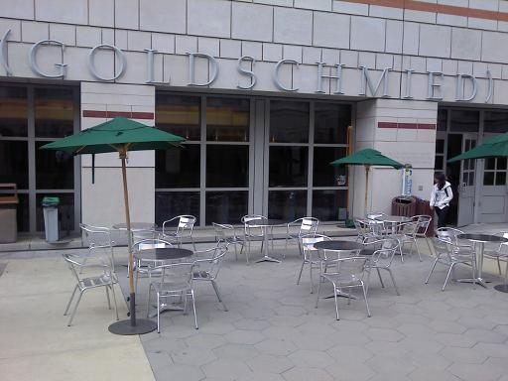 |  | Shop/Dept Name: |  | UCLA
 |  | Job Title(s): |  | UCLA Restaurant Employees
 |  | Analyzed by: |  | UCLA Restaurants
 |  | Date: |  | 1/1/2013
Required PPE:
N/A
Required/Recommended Trainings:
Review of JSA
TASK | HAZARDS |  | CONTROLS
- Ensure that weather conditions are appropriate for setting up patio umbrellas. | Windy conditions |  | - Do not set up if windy conditions are present
- If task 1 is met, proceed with setting the umbrella into metal stand/base. | Umbrella not properly secured into metal stand/base |  | - Tighten both screws on metal stand/base  - Periodic visual inspections of umbrellas throughout the day
- Open umbrella. | Make sure you are clear to open umbrella |  | - Make sure there is adequate space to perform the task.  - If no one is near, hold base of umbrella, lift umbrella body to its highest level and insert pin in hole.
- Inspect umbrellas and weather conditions periodically throughout the day. | Changing weather conditions - Wind occurring  Umbrellas being tampered with by the general public |  | - If windy conditions are present, close umbrella and tie up.  - If umbrella has been moved/tampered with, re-inspect to make sure it is properly secured into metal stand/base.
- Closing umbrella at the end of the day. | Leave up over night |  | - Make sure there is adequate space to perform the task.  - Lift umbrella body up, remove pin, tie umbrella up, unscrew safety screws, remove umbrella and store for the evening.

THIS PAGE INTENTIONALLY LEFT BLANK.

Injury & Illness Prevention Program
Injury & Illness Reporting Procedures
501 Westwood Plaza, 4th Fl • Los Angeles, CA 90095 • Ph: 310-825-5689 • Fx: 310-825-7076 • www.ehs.ucla.edu

Employees who are injured or become ill at work must report the injury or illness immediately to their supervisor and personnel department. Follow the procedures below as appropriate for the situation:

- Get the employee medical attention

- For non-emergency medical treatment for work-related injuries or illnesses

    - Between 7:30 AM and 4:30 PM Monday-Friday, send the employee to the Occupational Health Facility (OHF) at 67-120 CHS, 10833 Le Conte Avenue (Telephone 310-825-6771)
    - After OHF hours, use the Emergency Department (ED) at Ronald Reagan/UCLA Medical Center (RRMC), 757 Westwood Plaza, ER entrance off Gayley Avenue, north of Le Conte. (Telephone 310-267-8400).
    - If working off the main UCLA campus, use the nearest designated medical facility for your organization. Your Human Resources consultant can direct you to the appropriate facility.

- Immediate medical treatment beyond first aid

- Call 911 from a campus phone, or 310-825-1491 from off-campus or from your cell phone to contact UCPD dispatch.
- UCPD Dispatch will send medical responders to transport the employee to the appropriate hospital or medical center.

- Complete the “UCLA Incident Report & Referral for Medical Treatment” form

- Employee and/or supervisor should complete and sign the top two sections.
- Send the form with the employee to the medical provider or facility.
- The doctor or medical provider will complete the bottom section of the form indicating type of treatment provided, return to work status, work restrictions, and any future appointments.
- The employee should return the form to the supervisor (if the supervisor does not accompany the employee to the medical facility).
- The employer should try to accommodate any temporary work restrictions.
- If there are questions concerning work restrictions and accommodation, contact the Transitional Return to Work Coordinator at 310-794-6955.

- If the injury is more than first aid treatment, provide the following forms to the employee in addition to the “UCLA Incident Report & Referral for Medical Treatment” form:

- “Workers’ Compensation Claims Form (DWC-1) & Notice of Potential Eligibility” form

- Supervisor should complete bottom section 9 through 17, sign the form, and give to employee. Keep a copy of the completed form for department records, and send a copy to Payroll/Personnel and Insurance and Risk Management.
- Employee should complete top section of form and return to employer.

- Report injuries

- All injuries must be reported to Insurance and Risk Management within 24 hours

    - Call 877-682-7778 to report injuries 24/7
    - FAX completed forms to 310-794-6957
    - If available, report injury electronically by using Electronic First Report at https://ehs.ucop.edu/efr.

      - UCLA Incident Report and Referral for Medical Treatment (Appendix A)
      - Workers’ Compensation Claim Form (DWC 1) (Appendix A)

Serious Injuries

Serious occupational injuries, illnesses or exposures to hazardous substances, as defined by Cal/OSHA, must be reported to EH&S immediately when they become known to managers or supervisors.

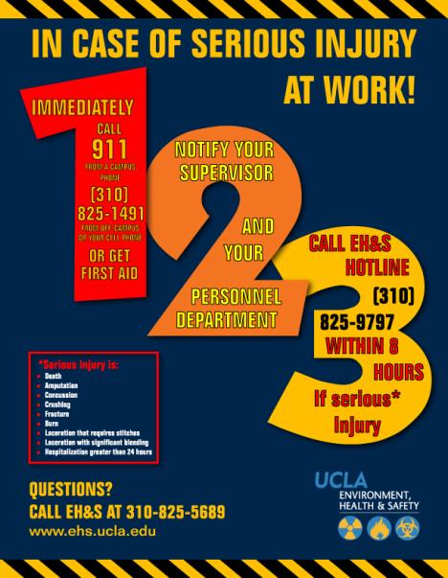
Serious injuries include amputations, concussions, crush injuries, fractures, burns, lacerations with significant bleeding or requiring stitches, or hospitalization (other than for observation) for greater than 24 hours. Call the EH&S Hotline at 310-825-9797 to report any injury that you think meets the Cal-OSHA definition of a serious injury.

Information required includes:
- name of the injured employee
- brief summary of the incident
- description of injuries obtained
- phone number where the reporting supervisor can be reached

EH&S must report the injury to Cal-OSHA within eight (8) hours of occurrence. Departments are responsible for a minimum payment of a $5000 fine for late reporting. An incident investigation will be conducted by EH&S in conjunction with a representative from the injured employee’s department.

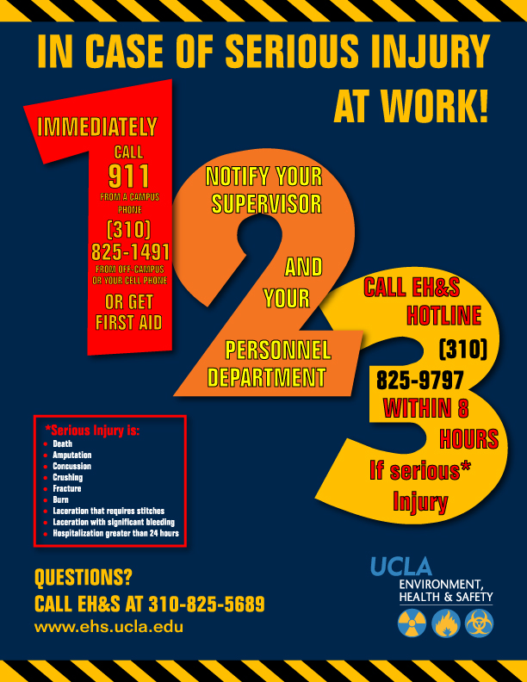

THIS PAGE INTENTIONALLY LEFT BLANK.
Injury & Illness Prevention Program
Injury Reporting and Treatment Flowchart
501 Westwood Plaza, 4th Fl • Los Angeles, CA 90095 • Ph: 310-825-5689 • Fx: 310-825-7076 • www.ehs.ucla.edu
START
Call 911 AND SEEK MEDICAL CARE immediately
Contact
EH&S Hotline within 8 hours of incident at x59797
Is the injury serious?*
*Serious injuries include: amputation, burn, concussion, crushing, death, fracture, hospitalization greater than 24 hours, and laceration with significant bleeding and/or that requires stitches.
Notify supervisor

Research related biological or recombinant DNA exposure?
Notify supervisor
Student?
Contact Insurance and Risk Management (IRM)
within 24 hours of incident at x46948
Contact EH&S Biosafety within 24 hours of incident at biosafety@ehs.ucla.edu x63929
Go to Arthur Ashe Student Health and Wellness Center (x54073).

Off-hours:
Ronald Reagan UCLA Emergency Medical Center (x52111) or pre-designated facility.
Go to Occupational Health Facility (x56771) or pre-designated facility.

Off-hours:
Ronald Reagan UCLA Emergency Medical Center (x52111) or pre-designated facility.
Complete Incident Report & Referral for Medical Treatment Form and take to treatment facility.
YES
NO
YES
NO
NO
YES
Complete Incident Report & Referral for Medical Treatment Form

THIS PAGE INTENTIONALLY LEFT BLANK.

University of California Los Angeles
INCIDENT REPORT & REFERRAL FOR MEDICAL TREATMENT
Incident Reporting is required and ensures that there is a record on file with the employer. If an employee is injured or develops a job-related illness (developed gradually over time) as a result of their employment at UC, they must complete and submit this form. If the employee is unable to complete this form, the supervisor must complete it on their behalf. If an injury occurs, first aid may be the appropriate treatment. If you have any questions, please call your Campus Workers’ Compensation representative at: Insurance & Risk Management (IRM) 310-794-6948 or Health System Human Resources (HS/HR) 310-794-0500. EMPLOYEE: Return this form to your department after you have been seen at the Occupational Health Facility (OHF) DEPARTMENT: within 1 day of the incident, Call 877-682-7778 24 hr report or Fax to 310-794-6957 or Email to wcreports@irm.ucla.edu

Employee Completes THIS Section:
Date of report: ____________________ Check one UCLA Campus UCLA Medical Center Santa Monica UCLA NPH/I
Sex: Male Female Check one Part-time Full-time Student Volunteer
Name PRINT: Last __________________________________ First ___________________________ SSN __________________________
Home Address: _________________________________________ City: ___________________________ Zip: _____________________
Home Phone: _______________________________________ Work Hours (Shift): _____________________________________________
Department: ____________________________ Job Title: ___________________ Work phone: ___________________________________
Do you have other employment? Yes No If yes, where: _____________________________________________________________
Date of Incident: _______________Time of Incident: _______AM_PM Describe what you were doing: ____________________________
________________________________________________________________________________________________________________
Describe all injured body parts (e.g. bruised elbow): ______________________________________________________________________
Were there witnesses? Yes No Unknown Name(s):____________________________________________________________
Is this a new injury? Yes No If “no”, please indicate date of original injury: _____________________________________________
INITIAL MEDICAL TREATMENT
No medical treatment; reporting only Declined treatment at this time Treatment was/will be provided
Treatment was provided by: Self Occupational Health Emergency Room Other (please specify below)
Name: __________________________________________________________________________________________________________
Address: _____________________________________________________ Phone: ___________________________________________
I, the injured employee, herein certify the information above is true and to best of my knowledge:
Date: _______________________ Signature of Employee: ______________________________________________________________

SUPERVISOR/EMPLOYEE COMPLETES THIS SECTION:
Supervisor Name: ________________________________________ Email address: ____________________________________________
Work Phone: _______________ Was the incident reported to you? Yes No Date reported: _________________________________
Address/Bldg, name & room # where the incident occurred: ________________________________________________________________
Describe how the employee was injured: _______________________________________________________________________________
________________________________________________________________________________________________________________
Did employee lose time from work? Yes No Unknown First day off work due to injury: ________________________________
Was the Employee paid for the full date of injury? Yes No Date Employee returned to work: ________________________________
Was equipment/chemical involved? Yes No If answered “yes” what was the equipment/chemical:_____________________________
________________________________________________________________________________________________________________
Was employee exposed to blood/bodily fluid other than his/her own? Yes No Source name/MR # _____________________________
What action will be taken to prevent recurrence? _________________________________________________________________________
Date: ________________ Supervisor Signature: ___________________________ Title: ______________________________________

MEDICAL PROVIDER COMPLETES THIS SECTION: Occupational Health Facility (OHF) Emergency Medicine Other Name/Address/Phone:_____________________________________________________________________________________________
What treatment was provided for this injury (check one) First Aid Medical Treatment
Return To Work: Can Return immediately Yes No Full duty Restrictions:___________________________________________
Date: __________________ Signature: __________________________________________ Title: ________________________________
REPORT ALL SERIOUS INJURIES TO EH&S HOTLINE 310-825-9797 Serious Injuries include death, loss of limb, burns, concussions, lacerations requiring stitches, crushes, fractures, and any hospitalization greater than 24-hours.

THIS PAGE INTENTIONALLY LEFT BLANK.
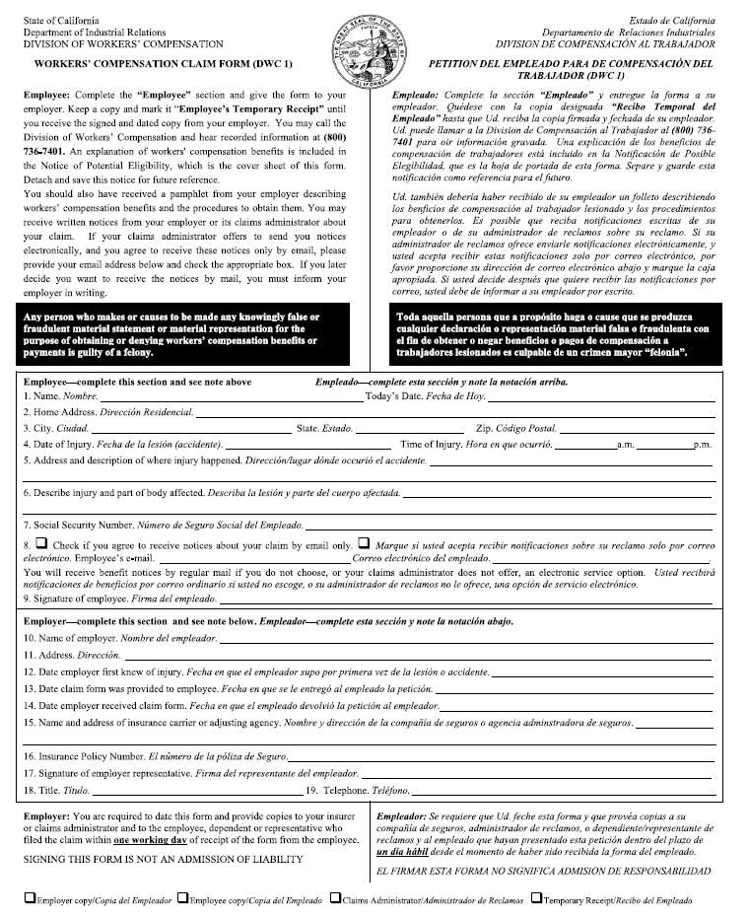

THIS PAGE INTENTIONALLY LEFT BLANK.
Injury and Illness Prevention Program
Incident Investigation
501 Westwood Plaza, 4th Fl • Los Angeles, CA 90095 • Ph: 310-825-5689 • Fx: 310-825-7076 • www.ehs.ucla.edu

Incident: | Report Only | Accident/Injury | Serious Injury | Other
Worker’s Compensation: | No | Yes | Claim No.

Injured Employee:
Name
Job Title/Department
Phone Number/Ext.
Date of Incident
Time of Incident
Location of Incident
Supervisor Name/Ext.
Interviewee(s):
 | Interviewee 1 |  | Interviewee 2
Name
Job Title/Department
Phone Number/Ext.
Investigator:
Name
Job Title/Department
Phone Number/Ext.
Date of Investigation
Incident Description
Contributors to Incident
Improper personal protective equipment |  | Employee inexperienced in job performed
Faulty or defective equipment/tools |  | Insufficient safety policies and trainings
Improper machine guarding |  | Employee not performing routine task
Hazards not identified
Identify equipment/tools used when incident occurred:
Hazardous weather conditions:
Other:

Results of Investigation
Did the employee receive medical treatment? Yes No
If yes, explain:
Is there lost time from work? Yes No
If yes, how many days:

Recommended Corrective Actions
Service/replace faulty equipment/tools. Identify:
Revise safety procedures for task
Provide appropriate PPE. Identify:
Complete job safety analysis. Topic:
Employee safety compliance review
Ergonomic Evaluation
Other:
Comments

Completed Corrective Actions
Safety training. Topic:
Serviced and/or replaced faulty equipment/tools. Identify:
Revised safety procedures for task
Provided appropriate PPE. Identify:
Complete job safety analysis. Topic:
Employee counseled/ disciplined
Ergonomic Evaluation
Other:

Attachments: (photos, additional documentation, etc.)

Injury and Illness Prevention Program
Incident Investigation – Training Documentation and Acknowledgment Form
501 Westwood Plaza, 4th Fl • Los Angeles, CA 90095 • Ph: 310-825-5689 • Fx: 310-825-7076 • www.ehs.ucla.edu

Claim: EXAMPLE: Doe, John SOM Anesthesiology DOI 5-15-13 Claim No. 2011011111

Purpose: Incident Investigation Report Review

Safety Topic (if applicable):
- Reporting Workplace Injuries
- xyz
- xyz

Supervisor/Facilitator Name: _____________________________________

Supervisor/Facilitator Signature: ____________________________________________________Date: ________________

By signing this form, I acknowledge that I have read and understood the contents of the Incident Investigation Report, Recommendations and/or Safety Topics referenced above.

A copy of this Incident Investigation Report shall be maintained in the departmental files for reference.

Employee Name | Employee Signature | Employee UCLA ID# | Date

*Add signature spaces as needed.

THIS PAGE INTENTIONALLY LEFT BLANK.
Injury & Illness Prevention Program
Guide for Completing Incident Investigations
501 Westwood Plaza, 4th Fl • Los Angeles, CA 90095 • Ph: 310-825-5689 • Fx: 310-825-7076 • www.ehs.ucla.edu

PURPOSE

When incidents occur on the job, an investigation must be completed to identify the root cause and contributing factors that led to the incident. Supervisors must complete any repairs and implement procedural changes to correct conditions contributing to the incident. Doing so will decrease the likelihood of the incident from reoccurring in the future. This handout summarizes the necessary steps in conducting an effective incident investigation, completing a thorough report and implementing the necessary corrective actions.

INCIDENT INVESTIGATION AND REPORT

- Investigate the incident as soon as possible.
  - This ensures that the gathered facts are fresh in the mind of the interviewee(s).

- Preserve the scene and document the investigation.
  - Document any physical changes observed at the incident site. Photograph or videotape the scene and potentially defective equipment so that the conditions of the incident are captured.

- If interviewing more than one person, conduct separate meetings with each interviewee.
  - This improves accuracy in that it allows interviewees to develop their own statements without being influenced by statements provided by others.

- Be very detailed and include specifics in the investigation report.
  - Who?
    - Incidents usually involve more people than just the injured employee. This includes witnesses and persons who may have contributed to the incident.
  - What?
    - Verify what the employee was doing when the incident occurred. What specific task was the employee performing? What equipment was involved? Was the proper training completed?
  - When?
    - It is important to indicate the time and date the incident occurred. This provides an idea of the turnaround time in which injuries are being reported. This is especially important for OSHA recordable injuries, which are time sensitive.
  - Where?
    - Be as detailed as possible when describing the scene of the incident. Make note of spilled contents on the floor, cords across walkways, and other observed hazards. Indicate whether or not the employee was in his/her common work area or performing a task in another work environment.
  - Why?
    - Compile all of the above information to develop an objective reason as to how and why the incident occurred. Why was the employee performing that task? Why did the equipment malfunction? Was it a defective piece of equipment or a user error?

IMPLEMENTING CORRECTIVE ACTIONS

- Review the incident investigation report and document corrective actions.
  - Determine the root cause of the incident and identify what can be done differently to reduce the likelihood of reoccurrence. Discuss the specific events that may have led to the incident. Exhaust the question “why?” until the root cause is identified. Refer to the example below:
    - Incident: Joe was using a ladder to perform a routine maintenance task in the warehouse when Paul came by on a forklift and ran into the ladder, causing Joe to fall.
      - Why was the ladder hit by the forklift?
        - The operator did not see Joe.
      - Why did Paul not see Joe?
        - The operator was transporting a large load that blocked his vision.
      - Why was the load blocking Paul’s vision?
        - He was driving forward instead of backwards as trained to do so when operating with a large load.
      - Why was Paul driving forward instead of backwards?
        - Paul had forgotten this rule regarding safe forklift operation procedures.
  - Review contents of the incident investigation report with the safety committee and identify possible solutions. Some general corrective actions may include the following:
    - Repair and/or replacement of faulty equipment per lock out/tag out procedures.
    - Revision to current safety procedures associated with job task (implement 2-man lifts, spotters for forklift operators, job rotation, etc.)
    - Disciplinary actions for violation of safety protocol (documentation of verbal warning and/or write up, suspension from job or termination).
    - Job hazard analysis outlining known hazards associated with job task and preventative actions for each.
    - The following are some solutions for the example presented above:
      - Refresher safety training for forklift operators and warehouse employees.
      - Have a helper at the foot of the ladder who can warn oncoming traffic.
      - Have a spotter for forklift operators.
      - Notify warehouse when maintenance work will be performed.
  - Follow up procedures must be in place to ensure the timely completion of corrective actions:
    - As best practices, a 30-day completion period should be applied to safety recommendations.
    - Intermittent corrective actions should be applied to hazards posing immediate exposures until recommendations can be completed (stanchion posts delineating unlevel flooring, cones around spills, LO/TO of machine with no guards, etc.).

* Investigative reports should be retained by the Department Safety Coordinator for five years. The Office of Environment, Health & Safety (EH&S) is available for and assistance to remedy any outstanding problems.

Contact Information:
EH&S Injury Prevention Division
Tel: 310-825-5689
www.ehs.ucla.edu

Injury & Illness Prevention Program
Disciplinary Action Guidelines
501 Westwood Plaza, 4th Fl • Los Angeles, CA 90095 • Ph: 310-825-5689 • Fx: 310-825-7076 • www.ehs.ucla.edu

Per UC Procedure 62, corrective action is intended to improve and/or correct the conduct or performance of regular status professional and support staff members. Supervisors shall apply necessary and appropriate corrective action whenever an employee fails to meet the required standards of conduct or performance. Consult your HR representative before implementing disciplinary action.

TYPES OF CORRECTIVE ACTION

Corrective actions include but are not limited to written warnings, corrective salary decreases, demotions, suspensions and termination.

For exempt employees, suspension without pay may be imposed only in increments of one workweek. However, suspension without pay in increments of less than a workweek may be permitted when the infraction is a violation of a significant safety rule relating to prevention of serious danger to the workplace or other employees.

- WRITTEN WARNING

At least one written warning shall precede any other more serious corrective action except when corrective action is the result of performance or conduct which an employee knows or reasonably should have known was unsatisfactory. Such performance or conduct may include but is not limited to violations of law, dishonesty, theft or misappropriation of University property, fighting on the job, insubordination, acts endangering others, or other serious misconduct.

- WRITTEN NOTICE OF INTENT TO TAKE CORRECTIVE ACTION

Written notice of intent to take corrective action is required, except for a written warning or a suspension pursuant to Staff Policy 64.D. The notice shall state the intended action, the reason, and the effective date, and shall include a copy of the materials on which the corrective action is based and state the employee's right to respond orally or in writing within 8 calendar days from the date of issuance of the notice.

After consideration of the employee's response, if any, the employee shall be notified in writing of the action to be taken, the effective date of the action, and the employee's right to review under Staff Policy 70, Complaint Resolution.

- RECORDS OF CORRECTIVE ACTIONS

Records of corrective actions shall be maintained in accordance with local procedures, except that records of corrective actions taken in response to complaints filed by a member of the public against employees in police titles shall be retained for at least five years and shall be filed as required by California Penal Code Section 832.5.

THIS PAGE INTENTIONALLY LEFT BLANK.

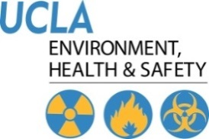 | Laboratory Safety  Laboratory Inspection Checklist
501 Westwood Plaza, 4th Floor • Los Angeles, CA 90095
Phone: 310-825-5689 • Fax: 310-825-7076 • www.ehs.ucla.edu

Date

Lab Information
Department
Principal investigator (PI)
PI telephone number
PI email address
Building
Lab room numbers
Lab Safety contact person
Lab Safety contact telephone number
Lab Safety contact email address
Lab phone number

 | Radiation |  | Biosafety 2 or greater |  | Lasers |  | Animals

Chemical Types Present
 | Particularly Hazardous Substances (select carcinogens, acute toxicants, reproductive toxicants) |  | Flammables
 | Regulated carcinogens |  | Explosives
 | Pyrophorics |  | Peroxide Formers
 | Water Reactives |  | Corrosives

Personnel Information
First Name | Last Name | UID

Inspection Information
Inspector
Inspector email address
Accompanied by

Documentation & Training
1 | 0 | S | N/A | Inspected | Comments
 |  |  |  | Current Lab Safety Manual is accessible. CHP should be read and understood. Training documented with signature and date.
 |  |  |  | Current Lab Hazard Assessment Tool (LHAT) updated, signed and located inside Lab Safety Manual
 |  |  |  | Initial and/or refresher EH&S Safety training documented
 |  |  |  | Lab Site Safety Orientation complete, documented and located inside Lab Safety Manual
 |  |  |  | Lab Specific Safety training documented and sufficient to cover lab operations
 |  |  |  | Initial and annual training for respirator users
 |  |  |  | Documented Fire Extinguisher Training
 |  |  |  | Laboratory accidents documented

Hazard Communication
1 | 0 | S | N/A | Inspected | Comments
 |  |  |  | SDS accessible (i.e., hard copy or on-line). Location known to all lab personnel.
 |  |  |  | SOP available (experiment/equipment/ hazardous activity). Should be signed by the PI and respective users.
 |  |  |  | Containers labeled with contents (full name, hazard warning, and date; no conflicting labels)
 |  |  |  | Current chemical inventory accessible
 |  |  |  | Chemical storage cabinets labeled (i.e., corrosives, flammables, etc…)
Emergency & Safety Information
1 | 0 | S | N/A | Inspected | Comments
 |  |  |  | Emergency assistance and 1,2,3 posters accessible in lab
 |  |  |  | NFPA fire diamond posted
 |  |  |  | NFPA fire diamond updated with current occupants & emergency contacts

Fire Safety
1 | 0 | S | N/A | Inspected | Comments
 |  |  |  | Storage clearance from ceiling: 18” with sprinklers, 24” without sprinklers
 |  |  |  | Fire extinguisher present/charged/accessible
 |  |  |  | Fire extinguisher tag updated; signage clearly visible

General Safety
1 | 0 | S | N/A | Inspected | Comments
 |  |  |  | Exits/aisles/corridors are not blocked (24” minimum width)
 |  |  |  | Laboratory doors kept closed
 |  |  |  | Approved safety shower & eyewash station accessible within 10 seconds (travel distance no greater than 100 feet)
 |  |  |  | Emergency shower / Eyewash Station inspected monthly
 |  |  |  | Clearance area around safety shower at least 16” in each direction. Signage clearly visible.
 |  |  |  | First-aid kit present, stocked and without expired products
 |  |  |  | Chemical spill material or kit available, spill procedures known to staff. Chemical spill kit should include necessary neutralizers.
 |  |  |  | Gas cylinders secured upright with double chains to a stable structure (i.e., wall or with clam shell/frame casing.)
 |  |  |  | Gas cylinder valve protection cap in place when not in use
 |  |  |  | Refrigerators/freezers labeled with food and drink specifications
 |  |  |  | Sink available for hand washing
 |  |  |  | Engineering controls functional

Personal Protective Equipment (PPE)
1 | 0 | S | N/A | Inspected | Comments
 |  |  |  | Closed-toe shoes and long pants worn by laboratory personnel as required by campus PPE policy 905
 |  |  |  | Lab coats worn as required by campus PPE policy 905
 |  |  |  | Gloves worn as required by campus PPE policy 905
 |  |  |  | Eye protection worn as required by campus PPE policy 905 (Goggles must be worn for procedures involving chemical splashes)
 |  |  |  | Adequate supply of specialty PPE available (i.e. UV/IR glasses, face shields, lab aprons, cryogenic gloves)
 |  |  |  | PPE contaminated with extremely hazardous materials disposed of as Haz Waste

Housekeeping
1 | 0 | S | N/A | Inspected | Comments
 |  |  |  | No food or drink in lab areas
 |  |  |  | Secondary containment provided for floor storage of glass bottles that contain chemicals.
 |  |  |  | Minimal glassware on bench top
 |  |  |  | Minimal glassware in sink
 |  |  |  | Minimal glassware in fume hood
 |  |  |  | Proper waste disposal of sharps (broken glass, pipettes, needles, razors, etc)
 |  |  |  | Sharps containers less than ¾ full

Chemical Storage and Compatibility
1 | 0 | S | N/A | Inspected | Comments
 |  |  |  | Less than 10 gallons of flammables located outside flammable storage cabinet
 |  |  |  | Maximum of 60 gallons flammable liquids per flammable storage cabinet, maximum of 3 flammable storage cabinets per lab/fire area.
 |  |  |  | Flammable storage refrigerator/freezer approved and labeled
 |  |  |  | Minimal acids stored outside corrosive cabinet
 |  |  |  | Strong acids and strong bases stored in secondary containers
 |  |  |  | Incompatible materials properly segregated
 |  |  |  | Chemicals stored safely (e.g. seismic restraints, etc.)
 |  |  |  | Combustible materials not stored with flammable chemicals
 |  |  |  | Chemical containers in good condition
 |  |  |  | Corrosive chemicals stored below eye level
 |  |  |  | Ethers and other peroxide formers dated
 |  |  |  | Water reactive chemicals segregated, contained, and labeled
 |  |  |  | Carcinogens segregated and stored in designated areas.
 |  |  |  | Pyrophoric chemicals segregated, contained, and labeled

Fume Hoods
1 | 0 | S | N/A | Inspected | Comments
 |  |  |  | Certified within one year
 |  |  |  | Proper sash height indicated
 |  |  |  | Sash at or below marked approval level
 |  |  |  | Sash stoppers functional where present
 |  |  |  | Hood illumination functional
 |  |  |  | Audible/visual alarm functional
 |  |  |  | Minimal clutter in hood (equipment, chemicals)
 |  |  |  | Functional fume hood not used for storage

Biosafety Cabinets
1 | 0 | S | N/A | Inspected | Comments
 |  |  |  | Certified within one year

Chemical Waste Disposal and Transport
1 | 0 | S | N/A | Inspected | Comments
 |  |  |  | Safety cans available and labeled for disposal of solvents
 |  |  |  | Containers available and labeled for disposal of hazardous waste
 |  |  |  | Content Section of waste tag be filled with full names. No abbreviations or formulas.
 |  |  |  | Waste tags attached to waste cans, containers
 |  |  |  | Chemical waste containers in good condition and kept closed (i.e. no funnels in place)
 |  |  |  | Sturdy cart available for transport of hazardous waste as needed
 |  |  |  | Hazardous waste in secondary containment
 |  |  |  | Designated hazardous waste storage areas
 |  |  |  | Chemical waste disposed when full or within 90 days, whichever is sooner
 |  |  |  | Dry hazardous waste double-bagged in transparent bags
 |  |  |  | Hazardous chemicals/materials not found in regular trash.

Seismic Safety
1 | 0 | S | N/A | Inspected | Comments
 |  |  |  | Shelving and file cabinets 5’ or over anchored/bolted
 |  |  |  | Storage shelves have seismic restraints (e.g. lips, bars, bungee cords)
 |  |  |  | High overhead storage is secured
 |  |  |  | Heavy items stored on lower shelves

Mechanical and Electrical Safety
1 | 0 | S | N/A | Inspected | Comments
 |  |  |  | Moveable parts guarded on equipment as appropriate
 |  |  |  | Electrical panel accessible
 |  |  |  | Nothing posted on electrical panel
 |  |  |  | Plugs, cords, outlets in good condition
 |  |  |  | No overloaded outlets, no daisy- chained power strips
 |  |  |  | Extension cords only present for immediate use and do not pose trip hazards (i.e., taped down, covered)
 |  |  |  | Power strips secured off the floor and away from liquids
 |  |  |  | No power cords found under doors, carpets, or through ceilings

Laboratory Safety
Inspection Process Flowchart
501 Westwood Plaza, 4th Fl • Los Angeles, CA 90095 • Ph: 310-825-5689 • Fx: 310-825-7076 • www.ehs.ucla.edu
KEY
RSM Research Safety Manager
AVC Assistant Vice Chancellor
VCR Vice Chancellor of Research
AVCR Associate Vice Chancellor of Research
FSR Facilities Services Request
START: Conduct Laboratory Inspection
Issue Stop Work Order
Immediately report to RSM, EH&S AVC
Issue inspection report w/in one business day and re-inspect w/in 30 days

Were deficiencies corrected?

Was FSR required/ issued?
Send FSR documentation to EH&S

Repeat Violation:
Re-inspect w/in 30 days; note repeat findings in report
Forward Report to Dept. Chair, RSM and EH&S AVC
Issue Report Next Day
Repeat this process as needed until all issues are resolved
Consult w/ RSM, EH&S AVC for lab closure. Closure will depend on severity of violation. Notify PI, Dept. Chair, Asst. Dean, Dean, AVCR and VCR
Report to PI, RSM, EH&S AVC, Dept. Chair, Asst. Dean, Dean, AVCR, VCR and re-inspect w/in 24 hours

Were critical deficiencies corrected?
Report to PI, RSM, EH&S AVC, Dept. Chair, Asst. Dean, Dean and re-inspect w/in 24 hours

Were any deficiencies critical?
Issue inspection report w/i one business day and re-inspect critical deficiencies w/in 48 hours

Immediately Dangerous to Life or Health?

Were critical deficiencies corrected?

Were critical deficiencies corrected?
YES

Were critical deficiencies corrected?
YES
YES
NO
NO
NO
NO
YES
YES
YES
NO
YES
NO
YES
NO
NO
YES

Deficiencies found?
NO
Report to PI, RSM, EH&S AVC, Dept. Chair, Asst. Dean, Dean, AVCR and re-inspect w/in 24 hours

THIS PAGE INTENTIONALLY LEFT BLANK.

Biosafety
Biosafety Level 1 Lab Assessment Tool
501 Westwood Plaza, 4th Fl • Los Angeles, CA 90095 • Ph: 310-825-5689 • Fx: 310-825-7076 • www.ehs.ucla.edu
Below is a self-assessment tool that can be used for BSL-1 laboratories. These basic microbiological standards are required as per the NIH Guidelines. Please fill out this assessment and return it signed to Biosafety at biosafety@ehs.ucla.edu
Date of Assessment: Completed by:
 | Yes | No | Comments
- Access to the laboratory is limited or restricted when experiments are in progress. | ☐ | ☐
- Lab personnel are provided hazard communication and training on standard microbiological practices prior to work and at least annually thereafter. | ☐ | ☐
- Work surfaces are decontaminated once a day and after a biological spill. | ☐ | ☐
- Mechanical pipetting devices are used; mouth pipetting is prohibited. | ☐ | ☐
- Eating, drinking, smoking, and applying cosmetics are not permitted in the work area. | ☐ | ☐
- Each laboratory contains a sink for hand washing, or means to sanitize hands before exiting the lab and persons wash their hands: (i) after they remove their gloves and (ii) before exiting the laboratory. | ☐ | ☐
- All procedures are performed carefully to minimize the creation of aerosols, splashes, and sprays. | ☐ | ☐
- Durable leak-proof secondary containers are used to transport material in public areas. | ☐ | ☐
- Personnel are dressed appropriately and PPE is provided that is appropriate for the risk. At a minimum this includes: long pants, closed toe shoes, lab coat, and disposable gloves. | ☐ | ☐
- Have all sharps been eliminated or substituted with non-sharps (i.e., plastic for glass) or safer sharp devices (i.e., retractable syringes). If not, have these been scientifically justified below? | ☐ | ☐ | Justification:
- The laboratory is designed so that it can be easily cleaned. (i.e. No cloth/porous chairs, or carpet). Spaces between benches, cabinets, and equipment are accessible for cleaning. Bench tops are impervious to water and resistant to chemicals. Laboratory furniture is sturdy. | ☐ | ☐
- If the laboratory has windows that open, they are fitted with fly screens. | ☐ | ☐
- If you are generating medical waste; please verify the following:
☐ Red biohazard bag fits securely in a secondary container.
☐ Secondary container is appropriately labeled (e.g. biohazard label on all lateral sides & top)
☐ Secondary container is rigid, leak-proof and is composed of a smooth and cleanable material that is non-porous.
☐ Secondary container has a tight fitting lid

(Please print form and sign below. A signed copy should be sent to Biosafety)
By signing below I attest that I have gone through this checklist in my lab and all the answers to the above questions are correct. I understand that meeting these BSL-1 standards is a requirement of my IBC approval. I understand that EH&S will be randomly verifying the results of this self-assessment.
Signature: Date:

Print Name: Lab Bldg & Room number:

Responsible PI:

THIS PAGE INTENTIONALLY LEFT BLANK.

Biosafety Inspection Checklist
Bloodborne Pathogens, BSL2 or BSL2+
501 Westwood Plaza, 4th Fl • Los Angeles, CA 90095 • Ph: 310-825-5689 • Fx: 310-825-7076 • www.ehs.ucla.edu

Date of Initial Inspection
Biosafety Inspector
Reason for Inspection | Pre-Inspection/Consultation New Application  Renewal Application Amendment  Other:

Laboratory Information
Department
Principal investigator (PI)
PI telephone number
PI email address
Building
Lab room number(s)
Lab Safety contact person
Lab Safety contact telephone number
Lab Safety contact email address
Lab phone number
If applicable, other laboratory personnel present during the inspection.

Summary of Biosafety Inspection Process
- The Biosafety inspection checklist is based on applicable federal, state, and local regulations involving the use, storage, transfer, and disposal of biohazard materials. This is a guide to certify the designated area for biohazard material(s) meets the requirements for containment facility and practices appropriate for the hazard and procedure.
- Inspection must be coordinated with EH&S Biosafety Staff to facilitate the necessary approval from the Institutional Biosafety Committee (IBC), who will issue the official laboratory approval prior to work with biohazard materials.
- Not all items on this checklist may be applicable to the designated biohazard area, but it is designed to identify immediately dangerous to life or health situations, serious deficiencies (must be addressed within 48 hours), and general deficiencies (must be addressed within 30 days).
- Serious deficiencies will not be applicable to new laboratories. If new laboratories still have deficiencies pending after 30 days, the lab can receive a “non-operational” approval from the IBC for grant or other purposes. Depending upon the deficiencies (e.g. non-safety issues), the IBC can consider approval with codicils to conduct biohazard work.
- Laboratories in operation with biohazard will need to have all deficiencies addressed within the required time frame to receive continuous IBC approval. If the deficiencies are not addressed, the inspector is required to report to appropriate Manager, Director, Committee Chair, Departmental Chair, Dean, et al. including the Vice Chancellor of Research depending upon the severity of the deficiencies. Upon reporting to and review by the IBC, the Committee can consider protocol inactivation/suspension or decommissioning of the designated biohazard laboratory.

SECTION 1: BIOSAFETY MANUAL
Laboratory Location(s) applicable to this section (make additional copies as needed)
Item for Compliance |  | N/A | 1 | 0 | C | Comments/Corrective Actions Completed
a | Biohazard Guidelines and Policies  (check all that apply)  NIH Guidelines (applicable containment)  BMBL (applicable containment)  BMBL (appendix H for the use of human or nonhuman primate materials)  Cal/OSHA BBP Standard  Cal/OSHA ATD Standard
b | Lab-Specific Exposure Control Plan  (check all that apply)  Bloodborne Pathogen  Aerosol Transmissible Disease  Zoonotic Materials  Other Communicable Disease
c | Standard Operating Procedures (use, storage, transport, and disposal including incident reporting and response)
d | MSDS for infectious agent(s)
e | MSDS for disinfectant
f | OSHA BBP Fact Sheets
g | Labworker HIV/BBP Info Card
h | Manual is available and accessible  Location manual is kept (if diff. than lab):
i | Sign-in sheet for personnel who have read the manual
j | Biosafety Approved Animal Research:  issued agent summary
k | medical waste procedure for animals/tissue
l | SOP for animal use and transport
m | Other (specify):
n | Other (specify):

SECTION 2: TRAINING AND MEDICAL SURVEILLANCE RECORDS
Laboratory Location(s) applicable to this section (make additional copies as needed)
Applicable Biosafety Training the lab needs to require per IBC application:
Biosafety Cabinet (recommended every 3 years) Bloodborne Pathogen (annually)
Biosafety Level 2 (every 3 years) Biosafety Level 2+ (every 3 years)
Biosafety Level 3 (annually) Respirator Training (annually)
Medical Waste Management (every 3 years) Shipping Biological Materials (every 2years)
Aerosol Transmissible Disease Standard (annually) Biological Toxins (once)
Monkey Bite Exposure Kit from DLAM (once)
Other:
Other:
Applicable Medical Surveillance per IBC application:
None Hepatitis B vaccination Vaccinia vaccination
Human Papilloma Virus vaccination Seasonal Flu Vaccine Orthopoxviruses (vaccinia & others)
Annual TB Testing Baseline Serum
Medical History Questionnaire (animal exposure) Medical History Questionnaire (respirator user)
Other: Other:
Documentation for Compliance |  | N/A | 1 | 0 | C | Comments/Corrective Actions Completed
a | Training records are available and kept current
b | Conducts Lab-specific training prior to start of work  - Laboratory Orientation  - Proficiency training for microbiological techniques and practices e.g., agent manipulation, equipment, etc  - Provides training education to high-risk personnel (e.g. pregnant, immune impaired)  Provided by:
c | Conducts annual/as needed lab training  Provided By:
d | Documentation of offered, consent, and declined vaccination/prophylaxis
e | Documentation of baseline serum participation
f | Documentation of TB testing participation
g | Other (specify):
h | Other (specify):

SECTION 3: CONTAINMENT AND PRACTICES
(make additional copies as needed)
Location (Bldg/Rm No) |  | Containment | Status of Biohazard Use |  |  |  |  | Lab Ownership
 |  | BSL 1  BSL 2  BSL 2+  BBP | Not in operation  In operation – no BH use  In operation – BH use  Other (specify): |  |  |  |  | Exclusive Use  Shared Use (specify main PI):  Core Facility (specify Director):
Section 3A: Emergency & Safety Information |  |  |  | N/A | 1 | 0 | C | Comments/Corrective Actions Completed
a | Biohazard doorcard is posted  - Containment Level  - PI/Alternate Contact and Phone  - Hazardous agents  - Entry/exit procedures
b | NFPA doorcard is current
c | Emergency assistance information is posted
d | Emergency contact after hours/weekends/holidays and reporting information are posted
e | Other (specify):
Section 3B: Laboratory Design |  |  |  | N/A | 1 | 0 | C | Comments/Corrective Actions Completed
a | Control Access (type)  key keycode proximity card  other (specify):
b | Lab door is self-closing
c | Lab door is kept closed while experiments are in progress (a must for BSL2+) – no doorstop
d | Ceiling is intact (e.g. no holes, no cracks, no missing tiles, etc. For new BSL2 approval, smooth, cleanable or non-porous.)
e | Wall is intact (e.g. no holes, no cracks, etc. For new BSL2 approval, durable glossy acrylic or epoxy paint.)
f | Floor is intact (e.g. no holes, no cracks, etc. For new BSL2+ lab, monolithic or sealed, coved)
g | Windows are not recommended. For windows that open to the exterior, must be fitted with screens
h | Illumination is adequate; no reflections or glare to impede vision
i | Work area is accessible for cleaning
j | Work area has no raw wood/cardboard/paper/rugs
k | Non-porous casework/shelves
l | Benchtops impervious to water and resistant to chemicals (no old desks or meeting tables, exposed wood)
m | Non-porous chair including stools
n | Sink is available with papertowels and soap  manual hands-free automatic  Location if not inside containment:
o | Eyewash station(s) meeting CAL/OSHA requirement – must be clutter free  Location if outside containment:
p | Eyewash station inspected monthly
q | Plants not associated with work are not present
r | Animals not associated with work are not present
s | Designated food and drinking area and storage (outside of the lab area)
t | Persons under 16 yrs of age shall not enter the laboratory (a must for BSL2+)
u | Other (specify):
Section 3C: Containment Equipment |  |  |  | N/A | 1 | 0 | C | Comments/Corrective Actions Completed
a | Biosafety Cabinet(s)  Type Certification Date
b | BSC is away from doors, windows, direct supply vents, and heavily traveled area
c | BSC is away from disruptive equipment
d | BSC is not a storage for lab supplies
e | All postings on the BSC can be decontaminated
f | No items on top of the BSC that could interfere with HEPA exhaust
g | No Bunsen burner inside the BSC
h | If flame is for experiment, explain:  Use:  Type:
i | Aspiration flask is inside the BSC
j | Vacuum line in BSC is HEPA filter protected
k | Bench top splash shields or enclosures (only if following universal precaution)
l | Aspiration flask on benchtops (only if following universal precaution)
m | Other Primary Containment:  Specify:  Certification Date:
n | Mechanical pipetting devices are used (no mouth pipetting)
o | Centrifuge (sealed rotor or safety cups is a must for BSL2/BSL2+)  Type of Centrifuge Tubes:  Screw cap plastic centrifuge tubes with O rings  Screw cap plastic centrifuge tubes  Other (specify):  Type of Rotor:  Sealed Rotor with O rings  Safety Cups with O rings  Other (specify):  Location if outside containment:
p | Other Aerosol Generating Equipment  Type(s)  Sonicator Blender Vortex  Other (specify):
q | Freezer  Lockable Secure room  Label with “no food/drink stored”  Location if outside containment:
r | Refrigerator  Lockable Secure room  Label with “no food/drink stored”  Location if outside containment:
s | Incubator  Location if outside containment:
t | Waterbath  Location if outside containment:
u | Microscope  Location if outside containment:
v | Leakproof Container  Primary Collection (no fliptop tubes)  Storage (no cardboard box)  2ndary Transport (no styrofoam, porous, etc)  Other (eg infected animals)  Specify:
w | All equipment has biohazard warning label(s) including storage and transport containers
x | Large equipments are seismically anchored (e.g. BSC, incubator, freezer)
y | Other (specify):
z | Other (specify):
Section 3D: Sharps |  |  |  | N/A | 1 | 0 | C | Comments/Corrective Actions Completed
a | Biohazard sharps container(s) present
b | All sharps containers less than ¾ full
c | Nonbiohazard sharps container  no biohazard sticker  “non-biohazard” label
d | Disposable plastic pipettes
e | Disposable glass pipettes
f | Type of Sharps Use:  Needle-free systems  Disposable needles  Needle-locking syringes  Needle-free injectors  Scalpels  Non-self sheathing scalpels  Self sheathing scalpels  Blunt-end sharps  Vacutainers  Other (specify):
g | Disposable plastic labwares (e.g. petri plates, flask, tubes, etc) – no glasswares
h | If glasswares are needed, explain:  Use: Type:  Method of Decontamination:
i | Other (specify):
Section 3E: Disposal and Decontamination |  |  |  | N/A | 1 | 0 | C | Comments/Corrective Actions Completed
a | Disinfectant – Hazard Specific  Name:  Concentration:  Contact Time:  Frequency:  Use: General Lab Equipment  Name:  Concentration:  Contact Time:  Frequency:  Use: General Lab Equipment
b | Red biohazard bags (properly fit the biohazard waste container)
c | Biohazard Waste Container(s)  Sanitary  Lid that fits (no swinging-top)  Non-porous (no cardboard, no safe keeper, etc)  Puncture-proof (no wire holders)  Label on all sides  Clear of non-biohazard items (i.e., nothing on top of the container)
d | Tools to pick-up biohazard sharps  broom/dustpan  tongs or forceps  other (specify):
e | Autoclave (a must for BSL2+)  Location:  Responsible Safety Manager:
f | Biohazard Waste Area (vendor’s tubs)  Location:
g | Access to accumulation waste area:  key key code (dept)  other (specify):
h | Other (specify):
i | Other (specify):
Section 3F: Personal Protective Equipment (PPE) |  |  |  | N/A | 1 | 0 | C | Comments/Corrective Actions Completed
a | Follows the Campus PPE Policy – minimum requirements worn at all times  - Full length pants or equivalent  - Close-toed shoes
b | Protective gloves are available  Nitrile  Latex  Powder and powder-less gloves avail.  Other (specify):
c | Utility gloves available (a must for autoclaving)
d | Laboratory coats or equivalent are available for all personnel  - Appropriately sized  - Cleaned and Maintained/Laundered
e | Disposable gowns (a must for BSL2+)  Type:
f | Eye Protection available for all personnel  Safety glasses  Goggles  Other (specify):
g | Surgical Mask (a must for BSL2+)
h | Respirator meeting NIOSH  Use:  Type(s):
i | Face shields (applicable to universal precaution or other high hazard procedure)
j | Other (specify):
k | Other (specify):

Section 3: Additional Comments

SECTION 4: INVENTORY AND TRANSFER RECORDS

Laboratory Location(s) applicable to this section (make additional copies as needed)

Responsible Receiver/Shipper
Item for Compliance |  | N/A | 1 | 0 | C | Comments/Corrective Actions Completed
a | List of Biohazardous Materials is maintained
b | Conducts inventory of biohazard materials coming, going, destroyed – update and review accuracy
c | Conducts security check of storage areas
d | Conducts review of access to biohazard materials
e | Type of Transfer  Intracampus Transfer

Shipment within the US

Domestic Transfer (non-permitted)

Domestic Transfer (permitted)

International Shipments

Export Permit

Import Permit
f | If the lab has shipped (in and out) any biohazard materials, are the shipping documents (e.g. declaration of dangerous goods) maintained for 2 years?  Location shipping records are kept:
g | IBC verification system is in place when sharing biohazard materials with collaborators
h | Other (specify):
i | Other (specify):

Biosafety Training / Inspection Checklist
Biological Toxins
501 Westwood Plaza, 4th Fl • Los Angeles, CA 90095 • Ph: 310-825-5689 • Fx: 310-825-7076 • www.ehs.ucla.edu

Date of Initial Inspection
Biosafety Inspector
Reason for Inspection | Pre-Inspection/Consultation New Application  Renewal Application Amendment  Other:

Laboratory Information
Department
Principal investigator (PI)
PI telephone number
PI email address
Building
Lab room number(s)
Lab Safety contact person
Lab Safety contact telephone number
Lab Safety contact email address
Lab phone number
If applicable, other laboratory personnel present during the inspection.

LIST OF BIOLOGICAL TOXINS USED:

GENERAL CONSIDERATIONS FOR TOXIN USE (Describe the work):

YES | NO | N/A
 |  |  | CDC/NIH Guidelines reviewed and understood (Appendix I).
 |  |  | Spill procedures are known and posted for specific agent. Spills/accidents resulting in overt or potential exposure to the infectious materials are immediately reported to the lab director and the UCLA Biosafety Office.
 |  |  | Emergency medical procedures known.
 |  |  | Medical surveillance program instituted.
 |  |  | Vaccination received/ serum banked.
 |  |  | Comments:
 |  |  | Each laboratory should develop a chemical hygiene plan specific to the toxin(s) used in that laboratory. The chemical hygiene plan should 1) identify the hazards that will be encountered in normal use of the toxin, and those that could be encountered in case of a spill or other accident, and 2) specify the policies and practices to be used to minimize risks (e.g., containment and personal protective equipment, management of spills, management of accidental exposures, medical surveillance).
 |  |  | Training
Training specific to the toxin(s) used should be required and documented for all laboratory personnel working with toxins, before starting work with the toxin and at intervals thereafter.
- Each laboratory worker must be trained in the theory and practice of the toxins to be used, with special emphasis on the nature of the practical hazards associated with laboratory operations.
- This includes how to handle transfers of liquids containing toxin, where to place waste solutions and contaminated materials or equipment, and how to decontaminate work areas after routine operations, as well as after accidental spills.
- The worker must be reliable and sufficiently adept at all required manipulations before being provided with toxin.

 |  |  | Special Training Consideration
 |  |  | If toxins and infectious agents are used together, then both must be considered when containment equipment is selected and safety procedures are developed.
 |  |  | Animal safety practices must be considered for toxin work involving animals.
 |  |  | Inventory and Access
 |  |  | An inventory control system should be in place.
 |  |  | Toxins should be stored in locked storage rooms, cabinets, or freezers when not in use.
 |  |  | Containers should be sealed, labeled.
 |  |  | Refrigerators and other storage containers should be clearly labeled and provide contact information for trained, responsible laboratory staff.
 |  |  | Access to areas containing toxins should be restricted to those whose work assignments require access (Personnel accessing the toxins).
 |  |  | Comments:
 |  |  | Operations
 |  |  | All high risk operations should be conducted with two knowledgeable individuals present. Each must be familiar with the applicable procedures, maintain visual contact with the other, and be ready to assist in the event of an accident.
 |  |  | Before containers are removed from the hood, cabinet, or glove box, the exterior of the closed primary container should be decontaminated and placed in a clean secondary container. Toxins should be transported only in leak/spill-proof secondary containers.
 |  |  | Comments:
 |  |  | Safety Equipment
 |  |  | The safety equipment guidelines listed under BSL 2 and BSL 3 (see Section III) should be reviewed and incorporated as appropriate into protocols for work with toxins.
 |  |  | Preparation of primary containers of toxin stock solutions and manipulations of primary containers of dry forms of toxins should be conducted in a chemical fume hood, a glove box, or a biological safety cabinet or equivalent containment system approved by the safety officer. HEPA and/or charcoal filtration of the exhaust air may be required, depending on the toxin.
Certified containment device available.
Type Certification date Building/room
 |  |  | The user should verify inward airflow of the hood or biological safety cabinet before initiating work.
 |  |  | All work should be done within the operationally effective zone of the hood or biological safety cabinet.
 |  |  | When using an open-fronted fume hood or biological safety cabinet, protective clothing, including gloves and a disposable long-sleeved body covering (gown, laboratory coat, smock, coverall, or similar garment) should be worn so that hands and arms are completely covered.
 |  |  | Eye protection should be worn if an open-fronted containment system is used.
 |  |  | Other protective equipment may be required, depending on the characteristics of the toxin and the containment system. For example, use additional respiratory protection if aerosols may be generated and it is not possible to use containment equipment or other engineering controls.
 |  |  | When handling toxins that are percutaneous hazards (irritants, necrotic to tissue, or extremely toxic from dermal exposure), select gloves that are known to be impervious to the toxin.
 |  |  | Consider both toxin and diluent when selecting gloves and other protective clothing.
 |  |  | Comments:
 |  |  | Laboratory Facilities
 |  |  | Laboratory facility recommendations listed under BSL 2 and BSL 3 (See Section III) and OSHA standards should be reviewed and incorporated as appropriate into protocols for work with toxins.
 |  |  | When toxins are in use, the room should be posted to indicate "Toxins in Use Authorized Personnel Only.'' Any special entry requirements should be posted on the entrance(s) to the room. Only personnel whose presence is required should be permitted in the room while toxins are in use.
 |  |  | Vacuum lines. When vacuum lines are used with systems containing toxins, they should be protected with a HEPA filter to prevent entry of toxins into the lines. Sink drains should be similarly protected when water aspirators are used.
 |  |  | Centrifugation of cultures or materials potentially containing toxins should only be performed using sealed, thick-walled tubes in safety centrifuge cups or sealed rotors. The outside surfaces of containers and rotors should be routinely cleaned before each use to prevent contamination that may generate an aerosol. After centrifugation, the entire rotor assembly is taken from the centrifuge to a BSC to open it and remove its tubes.
 |  |  | Sharps container present.
 |  |  | Tools to pick-up broken glass present: broom/dust pan, tongs, or forceps.
 |  |  | Glassware should be replaced with plastic for handling toxin solutions wherever practical to minimize the risk of cuts or abrasions from contaminated surfaces. Thin walled glass equipment should be completely avoided.
 |  |  | Glass Pasteur pipettes are particularly dangerous for transferring toxin solutions and should be replaced with disposable plastic pipettes.
 |  |  | Glass chromatography columns under pressure must be enclosed within a plastic water jacket or other secondary container.
 |  |  | Comments:
 |  |  | ADDITIONAL PRECAUTIONS
 |  |  | Work with dry toxins.
When handling dry forms of toxins that are electrostatic:
- Use glove bag within a hood or biological safety cabinet, a glove box, or a class III biological safety cabinet. Dry toxin can be manipulated using a Class III BSC, or with the use of secondary containment such as a disposable glove bag or glove box within a hood or Class II BSC.
- Appropriate respiratory protection and engineering controls.
- “Static-free” disposable gloves should be worn when working with dry forms of toxins that are subject to spread by electrostatic dispersal.
 |  |  | Experimental procedures using aersolization.
 |  |  | If infectious agents and toxins are used together in an experimental system, consider both when selecting protective clothing and equipment.
 |  |  | Comments:
 |  |  | Decontamination and Spills
 |  |  | Disinfectants used are appropriate for the surface, equipment and toxins use.
 |  |  | Contaminated and potentially contaminated protective clothing and equipment should be decontaminated using methods known to be effective against the toxin before removal from the laboratory for disposal, cleaning or repair. If decontamination is not possible/practical, materials (e.g., used gloves) should be disposed of as toxic waste. Materials contaminated with infectious agents as well as toxins should also be autoclaved or otherwise rendered non-infectious before leaving the laboratory.
 |  |  | The interior of the hood, glove box, or cabinet should be decontaminated periodically, for example, at the end of a series of related experiments.
 |  |  | Until decontaminated, the hood, box, or cabinet should be posted to indicate that toxins are in use, and access to the equipment and apparatus restricted to necessary, authorized personnel.
 |  |  | Inactivation with dilute sodium hydroxide (NaOH) at concentrations of 0.1-0.25N, and/or sodium hypochlorite (NaOCl) bleach solutions at concentrations of 0.1-0.5% (w/v).
 |  |  | Use freshly prepared bleach solutions for decontamination; undiluted, commercially available bleach solutions typically contain 3-6% (w/v) NaOCl.
 |  |  | Depending upon the toxin, contaminated materials and toxin waste solutions can be inactivated by incineration or extensive autoclaving, or by soaking in suitable decontamination solutions.
 |  |  | All disposable material used for toxin work should be placed in secondary containers, autoclaved and disposed of as toxic waste. Contaminated or potentially contaminated protective clothing and equipment should be decontaminated using suitable chemical methods or autoclaving before removal from the laboratory for disposal, cleaning or repair. If decontamination is impracticable, materials should be disposed of as toxic waste.
 |  |  | In the event of a spill, avoid splashes or generating aerosols during cleanup by covering the spill with paper towels or other disposable, absorbent material. Apply an appropriate decontamination solution to the spill, beginning at the perimeter and working towards the center, and allow sufficient contact time to completely inactivate the toxin.
 |  |  | Decontamination of buildings or offices containing sensitive equipment or documents poses special challenges. Large-scale decontamination is not covered explicitly here, but careful extrapolation from the basic principles may inform more extensive clean-up efforts.
 |  |  | Select Agent Toxins
 |  |  | Due diligence should be taken in shipment or storage of any amount of toxin. There are specific regulatory requirements for working with toxins designated as a “Select Agent” by the DHHS and/or the USDA. Select Agents require registration with CDC and/or USDA for possession, use, storage and/or transfer. Importation of this agent may require CDC and/or USDA importation permits. Domestic transport of the agent may require a permit from USDA/APHIS/VS. A DoC permit may be required for the export of the agent to another country.
 |  |  | SUMMARY CHECKLIST:
 |  |  | Emergency Procedure
 |  |  | Doorcard
 |  |  | Storage area (Labels)
 |  |  | MSDS/ Factsheet/SOP/Chemical Hygiene Plan
 |  |  | Biological Toxin Safety Checklist (BMBL – Appendix I)
 |  |  | Disposal chemical Procedure (Not poured into drain, chem waste tags)
 |  |  | Animal/Tissue Disposal Procedure (Red tags)
 |  |  | Training of New Personnel (Chemical Waste, Medical Waste, Biosafety)
 |  |  | Comments:

THIS PAGE INTENTIONALLY LEFT BLANK.

Biosafety Inspection Checklist
Animal Biosafety Level (ABSL)
501 Westwood Plaza, 4th Fl • Los Angeles, CA 90095 • Ph: 310-825-5689 • Fx: 310-825-7076 • www.ehs.ucla.edu
Date of Initial Inspection
Biosafety Inspector
Reason for Inspection | Pre-Inspection/Consultation New Application  Renewal Application Amendment  Other:

Laboratory Information
Department
Facility Director/ Principal investigator (PI)
Facility Director/ PI Phone number
Facility Director/ PI email address
Area Resource Supervisor (ARS)/ Manager
ARS/ Manager Phone number
ARS/ Manager Email
Lab Safety contact telephone number
Lab Safety contact email address
Lab phone number
If applicable, other personnel present during the inspection (name/title/email/phone)

Summary of Biosafety Inspection Process
- The Biosafety inspection checklist is based on applicable federal, state, and local regulations involving the use, storage, transfer, and disposal of biohazard materials. This is a guide to certify the designated area for biohazard material(s) meets the requirements for containment facility and practices appropriate for the hazard and procedure.
- Inspection must be coordinated with EH&S Biosafety Staff to facilitate the necessary approval from the Institutional Biosafety Committee (IBC), who will issue the official laboratory approval prior to work with biohazard materials.
- Not all items on this checklist may be applicable to the designated biohazard area, but it is designed to identify immediately dangerous to life or health situations, critical deficiencies (must be addressed within 48 hours), and general deficiencies (must be addressed within 30 days).
- Critical deficiencies will not be applicable to new laboratories. If new laboratories still have deficiencies pending after 30 days, the lab can receive a “non-operational” approval from the IBC for grant or other purposes. Depending upon the deficiencies (e.g. non-safety issues), the IBC can consider approval with codicils to conduct biohazard work.
- Laboratories in operation with biohazard will need to have all deficiencies addressed within the required time frame to receive continuous IBC approval. If the deficiencies are not addressed, the inspector is required to report to appropriate Manager, Director, Committee Chair, Departmental Chair, Dean, et al. including the Vice Chancellor of Research depending upon the severity of the deficiencies. Upon reporting to and review by the IBC, the Committee can consider protocol inactivation/suspension or decommissioning of the designated biohazard laboratory.

SECTION 1: BIOSAFETY MANUAL
Laboratory Location(s) applicable to this section (make additional copies as needed)
Item for Compliance |  | N/A | 1 | 0 | C | Comments/Corrective Actions Completed
a | An appropriate medical surveillance program is in place. All personnel receive appropriate immunizations or tests for the RG 2 agents handled or potentially present (e.g., hepatitis B vaccine, TB skin testing).
b | Written standard policies, procedures, and protocols for emergency situations established by the facility director.
c | Standard Operating Procedures (use, storage, transport, and disposal including incident reporting and response)
d | Spills and accidents which result in overt exposures to infectious materials must be immediately reported to the facility director. Spills of rDNA molecules which result in overt exposures are immediately reported to the Institutional Biosafety Committee and NIH/OBA.
e | Medical evaluation, surveillance, and treatment are provided as appropriate following an exposure and written records are maintained.
f | In general, persons who may be at increased risk of acquiring infection, or for whom infection might be unusually hazardous, are not allowed in the animal facility unless special procedures can eliminate the extra risk.
g | Personnel are advised of special hazards, and are required to read and follow instructions on practices and procedures.
h | The PI establishes policies and procedures whereby only persons who have been advised of the potential hazard and meet any specific entry requirements (i.e., immunizations) may enter the animal rooms.
i | Before entry, personnel who must enter the  room for program or service purposes when work is in progress are advised of the potential biohazards and are instructed on the appropriate safeguards.
j | A biosafety manual is prepared or adopted. Personnel are advised of special hazards, and are required to read and follow instructions on practices and procedures.
k | Each project is subject to pre-approval by IACUC and IBC. Any special practices are approved at this time.
l | An insect/rodent control program is in place.
m | Biosafety Approved Animal Research:  issued agent summary
n | medical waste procedure for animals/tissue
o | SOP for animal use and transport

SECTION 2: TRAINING AND MEDICAL SURVEILLANCE RECORDS
Laboratory Location(s) applicable to this section (make additional copies as needed)
Applicable Biosafety Training the lab needs to require per IBC application:
Biosafety Cabinet (recommended every 3 years) Bloodborne Pathogen (annually)
Biosafety Level 2 (every 3 years) Biosafety Level 2+ (every 3 years)
Biosafety Level 3 (annually) Respirator Training (annually)
Medical Waste Management (every 3 years) Shipping Biological Materials (every 2years)
Aerosol Transmissible Disease Standard (annually) Biological Toxins (once)
Monkey Bite Exposure Kit from DLAM (once)
Other: Other:
Applicable Medical Surveillance per IBC application:
None Hepatitis B vaccination Vaccinia vaccination
Human Papilloma Virus vaccination Seasonal Flu Vaccine Orthopoxviruses (vaccinia & others)
Annual TB Testing Baseline Serum
Medical History Questionnaire (animal exposure) Medical History Questionnaire (respirator user)
Other: Other:
Documentation for Compliance |  | N/A | 1 | 0 | C | Comments/Corrective Actions Completed
a | Training records are available & kept current
b | Conducts Lab-specific training prior to start of work  - Laboratory Orientation  - Proficiency training for microbiological techniques and practices e.g., agent manipulation, equipment, etc  - Provides training education to high-risk personnel (e.g. pregnant, immune impaired)  Provided by:
c | Conducts annual/as needed lab training  Provided By:
d | Documentation of offered, consent, and declined vaccination/prophylaxis
e | Documentation of baseline serum participation
f | Documentation of TB testing participation
g | Other (specify):
h | Other (specify):

Animal Biosafety Level Containment
According to the CDC/NIH Biosafety in Microbiological and Biomedical Laboratories (5th ed.), ABSL-2 builds upon the practices, procedures, containment equipment, and facility requirements of ABSL-1. ABSL-2 requires that: 1) access to the animal facility is restricted; 2) personal must have specific training in animal facility procedures, the handling of infected animals and the manipulation of pathogenic agents; 3) personal must be supervised by individuals with adequate knowledge of potential hazards, microbiological agents, animal manipulations and husbandry procedures; and 4) BSCs or other physical containment equipment is used when procedures involve the manipulation of infectious materials, or where aerosols or splashes may be created.
Containment |  | Building/Room | Animal Species |  | General Description of Biohazard Use and Procedure
ABSL-1  ABSL-1 with BSL2 practices  ABSL-2  ABSL-2 with BSL3 practices  ABSL-3 |  |  | Mice  Rats  Rabbits  Guinea Pigs  Fish  Other Species (identify):

SECTION 3: CONTAINMENT AND PRACTICES
(make additional copies as needed)
Location (Bldg/Rm No) |  | Containment | Status of Biohazard Use |  |  |  |  | Lab Ownership
 |  | ABSL 1  ABSL 2  ABSL 2+  BBP | Not in operation  In operation – no BH use  In operation – BH use  Other (specify): |  |  |  |  | Exclusive Use  Shared Use (specify main PI):  Core Facility (specify Director):
Section 3A: Emergency & Safety Information |  |  |  | N/A | 1 | 0 | C | Comments/Corrective Actions Completed
Biohazard doorcard is posted
- Containment Level
- PI/Alternate Contact and Phone
- Hazardous agents
- Entry/exit procedures
 | NFPA doorcard is current
 | Emergency assistance information is posted
 | Emergency contact after hours/weekends/holidays and reporting information are posted
 | Other (specify):
Section 3B: Laboratory Design |  |  |  | N/A | 1 | 0 | C | Comments/Corrective Actions Completed
Control Access (type)
key keycode proximity card
other (specify):
 | Lab door is self-closing and self-locking
 | Lab door is kept closed while experiments are in progress (a must for BSL2+) – no doorstop
 | Ceiling is intact (e.g. no holes, no cracks, no missing tiles, etc. For new BSL2 approval, smooth, cleanable or non-porous.)
 | Wall is intact (e.g. no holes, no cracks, etc. For new BSL2 approval, durable glossy acrylic or epoxy paint.)
 | Floor is intact (e.g. no holes, no cracks, etc. For new BSL2+ lab, monolithic or sealed, coved)
 | Windows are not recommended. For windows that open to the exterior, must be fitted with screens
 | Access to the animal room is limited to the fewest number of individuals possible. Only persons required for program or support purposes are authorized to enter the facility.
 | Access to the facility is limited by secure locked doors.
 | The animal facility is separated from areas that are open to unrestricted personnel traffic within the building.
 | Doors to animal rooms open inward
 | Illumination is adequate; no reflections or glare to impede vision
 | Work area is accessible for cleaning
 | The animal facility is designed, constructed, and maintained to facilitate cleaning and housekeeping. The interior surfaces (walls, floors, ceilings) are water resistant.
 | Work area has no raw wood/cardboard/paper/rugs
 | Non-porous casework/shelves
 | Benchtops impervious to water and resistant to chemicals (no old desks or meeting tables, exposed wood)
 | Non-porous chair including stools
Sink is available with papertowels and soap
manual hands-free automatic
Location if not inside containment:
Eyewash station(s) meeting CAL/OSHA requirement – must be clutter free
Location if outside containment:
 | Eyewash station inspected monthly
 | Plants not associated with work are not present
 | Animals not associated with work are not present
 | Designated food and drinking area and storage (outside of the lab area)
 | Persons under 16 yrs of age shall not enter the laboratory (a must for BSL2+)
 | Other (specify): The direction of airflow in the animal facility is inward; animal rooms should maintain negative pressure compared to adjoining hallways.
 | Other (specify): Ventilation should be provided in accordance with criteria from Guide for Care and Use of Laboratory Animals, latest edition
 | Other (specify): Cages are washed manually or in an appropriate cage washer. The mechanical cage washer should have a final rinse temperature of at least 180F.
Section 3C: Containment Equipment |  |  |  | N/A | 1 | 0 | C | Comments/Corrective Actions Completed
Biosafety Cabinet(s)
Type Certification Date

 | BSC is away from doors, windows, direct supply vents, and heavily traveled area
 | BSC is away from disruptive equipment
 | BSC is not a storage for lab supplies
 | All postings on the BSC can be decontaminated
 | No items on top of the BSC that could interfere with HEPA exhaust
 | No Bunsen burner inside the BSC
If flame is for experiment, explain:
Use:
Type:
 | Aspiration flask is inside the BSC
 | Vacuum line in BSC is HEPA filter protected
 | Bench top splash shields or enclosures (only if following universal precaution)
 | Aspiration flask on benchtops (only if following universal precaution)
Other Primary Containment:
Specify:
Certification Date:
 | Mechanical pipetting devices are used (no mouth pipetting)
Centrifuge (sealed rotor or safety cups is a must for BSL2/BSL2+)
Type of Centrifuge Tubes:
Screw cap plastic centrifuge tubes with O rings
Screw cap plastic centrifuge tubes
Other (specify):
Type of Rotor:
Sealed Rotor with O rings
Safety Cups with O rings
Other (specify):
Location if outside containment:
Other Aerosol Generating Equipment
Type(s)
Sonicator Blender Vortex
Other (specify):
Freezer
Lockable Secure room
Label with “no food/drink stored”
Location if outside containment:
Refrigerator
Lockable Secure room
Label with “no food/drink stored”
Location if outside containment:
Incubator
Location if outside containment:
Waterbath
Location if outside containment:
Microscope
Location if outside containment:
Leakproof Container
Primary Collection (no fliptop tubes)
Storage (no cardboard box)
2ndary Transport (no styrofoam, porous, etc)
Other (eg infected animals)
Specify:
 | All equipment has biohazard warning label(s) including storage and transport containers
 | Large equipments are seismically anchored (e.g. BSC, incubator, freezer)
 | Other (specify): animal housing and cages
 | Other (specify):
Section 3D: Sharps |  |  |  | N/A | 1 | 0 | C | Comments/Corrective Actions Completed
 | Biohazard sharps container(s) present
 | All sharps containers less than ¾ full
Nonbiohazard sharps container
no biohazard sticker
“non-biohazard” label
 | Disposable plastic pipettes
 | Disposable glass pipettes
Type of Sharps Use:
Needle-free systems
Disposable needles
Needle-locking syringes
Needle-free injectors
Scalpels
Non-self sheathing scalpels
Self sheathing scalpels
Blunt-end sharps
Vacutainers
Other (specify):
 | Disposable plastic labwares (e.g. petri plates, flask, tubes, etc) – no glasswares
If glasswares are needed, explain:
Use:
Type:
Method of Decontamination:
 | Other (specify):
Section 3E: Disposal and Decontamination |  |  |  | N/A | 1 | 0 | C | Comments/Corrective Actions Completed
Disinfectant – Hazard Specific
Name:
Concentration:
Contact Time:
Frequency:
Use: General Lab Equipment

Name:
Concentration:
Contact Time:
Frequency:
Use: General Lab Equipment
 | Red biohazard bags (properly fit the biohazard waste container)
Biohazard Waste Container(s)
Sanitary
Lid that fits (no swinging-top)
Non-porous (no cardboard, no safe keeper, etc)
Puncture-proof (no wire holders)
Label on all sides
Clear of non-biohazard items (i.e., nothing on top of the container)
Tools to pick-up biohazard sharps
broom/dustpan
tongs or forceps
other (specify):
Autoclave (a must for BSL2+)
Location:
Responsible Safety Manager:
Biohazard Waste Area (vendor’s tubs)
Location:
Access to accumulation waste area:
key key code (dept)
other (specify):
 | Other (specify):
 | Other (specify):
Section 3F: Personal Protective Equipment (PPE) |  |  |  | N/A | 1 | 0 | C | Comments/Corrective Actions Completed
Follows the Campus PPE Policy – minimum requirements worn at all times
- Full length pants or equivalent
- Close-toed shoes
Protective gloves are available
Nitrile
Latex
Powder and powder-less gloves available
Other (specify):
 | Utility gloves available (a must for autoclaving)
Laboratory coats or equivalent are available for all personnel
- Appropriately sized
- Cleaned and Maintained/Laundered
Disposable gowns (a must for BSL2+)
Type:
Eye Protection available for all personnel
Safety glasses
Goggles
Other (specify):
 | Surgical Mask (a must for BSL2+)
Respirator meeting NIOSH
Use:
Type(s):
 | Face shields (applicable to universal precaution or other high hazard procedure)
 | Other (specify): shoe covers
 | Other (specify): hair covers
 | Other (specify):

Section 3: Additional Comments

SECTION 4: INVENTORY AND TRANSFER RECORDS
Laboratory Location(s) applicable to this section (make additional copies as needed)
Responsible Receiver/Shipper
Item for Compliance |  | N/A | 1 | 0 | C | Comments/Corrective Actions Completed
a | List of Biohazardous Materials is maintained
b | Conducts inventory of biohazard materials coming, going, destroyed – update and review accuracy
c | Conducts security check of storage areas
d | Conducts review of access to biohazard materials
e | Type of Transfer  - Intracampus Transfer
- Shipment within the US
Domestic Transfer (non-permitted)
Domestic Transfer (permitted)
- International Shipments
Export Permit
Import Permit
f | If the lab has shipped (in and out) any biohazard materials, are the shipping documents (e.g. declaration of dangerous goods) maintained for 2 years?  Location shipping records are kept:
g | IBC verification system is in place when sharing biohazard materials with collaborators
h | Other (specify):
i | Other (specify):

THIS PAGE INTENTIONALLY LEFT BLANK.

Principal Investigator: |  | LA No.:
Surveyor: |  | Dept.:
Locations: |  | Date:
Radiation Safety
Radiation Use Authorization
Radiation Summary Checklist
501 Westwood Plaza, 4th Fl • Los Angeles, CA 90095 • Ph: 310-825-5689 • Fx: 310-825-7076 • www.ehs.ucla.edu
Your radioactive materials use areas were surveyed today, and a summary of the results is given below:
RADIATION SAFETY
S | U | NA | [S = Satisfactory , U = Unsatisfactory, Y = Yes, N = No, NA = Not Applicable]
☐ | ☐ | ☐ | Contamination levels within acceptable limits.
☐ | ☐ | ☐ | Radiation protection manual available.
☐ | ☐ | ☐ | Monthly surveys. ☐ “No use” statements only.
☐ | ☐ | ☐ | Isotope inventory.
☐ | ☐ | ☐ | Survey instruments.
☐ | ☐ | ☐ | Dosimeters properly utilized.
☐ | ☐ | ☐ | Proper storage and handling of waste.
☐ | ☐ | ☐ | Security of radioactive materials.
☐ | ☐ | ☐ | Work areas, equipment, and isotope storage properly labeled.
☐ | ☐ | ☐ | Appropriate shielding in use.
☐ | ☐ | ☐ | Only authorized personnel working with isotopes.
☐ | ☐ | ☐ | Visitors, volunteers, and peripheral workers have received hazard awareness training.
☐ | ☐ | ☐ | Only authorized rooms being used for isotope work.
☐ | ☐ | ☐ | General conditions of radioactive materials work areas.

GENERAL SAFETY
S | U | NA | [S = Satisfactory , U = Unsatisfactory, Y = Yes, N = No, NA = Not Applicable]
☐ | ☐ | ☐ | Food and drink policy followed. Includes proper labeling of refrigerators, freezers, and microwaves.
☐ | ☐ | ☐ | Lab personnel utilizing PPE in accordance with UCLA Policy 905.
 |  |  | Last date of Laboratory Hazard Assessment Tool completion: __________________________________________

Comments:
Please take immediate action to remedy any problems found during this survey.

Note: An unsatisfactory mark for contamination, food & drink, or PPE results in a serious finding which requires a resolution within 48 hours of the survey audit. Failure to resolve may result in escalating the issue to the Radiation Safety Officer, Assistant Vice Chancellor of EH&S, Department Chair, Assistant Dean, Dean, and the Office of the Vice Chancellor of Research.

RSD Use Only: HP___________________
THIS PAGE INTENTIONALLY LEFT BLANK.

Radiation Safety
Laser Inspection Checklist
501 Westwood Plaza, 4th Fl • Los Angeles, CA 90095 • Ph: 310-825-5689 • Fx: 310-825-7076 • www.ehs.ucla.edu

Attach Laser Survey Information Sheet (contains location, equipment, worker and survey details) to checklist.

Laser Lab Information
Principal Investigator (PI)
Department
Building
Lab Room Number(s)

Inspection Information
Inspection Date
Inspector
Inspector Email
Inspector Phone
Laboratory Representative
Lab Rep Email
Lab Rep Phone
Laser Class(es) Found | 1E (enclosed) | 2 | 3R | 3B | 4

Documentation & Training
1 | 0 | C | N/A | Inspected | Class | Notes
 |  |  |  | EH&S Laser Safety Training current and documented for authorized users | 1M-4
 |  |  |  | Laser Worker Training Information documented, sufficient to address laser and high voltage operations, and signed by lab laser users | ALL
 |  |  |  | Laser Worker Training Log available and current for laser users | ALL
 |  |  |  | Authorized User List available and current for authorized personnel | ALL
 |  |  |  | Hazard Awareness Information documented and signed by lab workers who are not laser users | ALL
 |  |  |  | Service Provider List: qualification and training for class of embedded laser | 1E
 |  |  |  | Laser Safety Manual accessible to all laboratory personnel | ALL
 |  |  |  | Laboratory laser accidents/incidents documented | ALL
 |  |  |  | Hazard Assessment Tool updated and located inside Lab Safety Manual | ALL

Hazard Communication
1 | 0 | C | N/A | Inspected | Class | Notes
 |  |  |  | SOP available for each class of laser (experiment/equipment/hazardous activity) | 1E  3B,4
 |  |  |  | Alignment Procedure available | 1E  3B,4
 |  |  |  | Rapid Shutdown Procedure available | 3B,4
 |  |  |  | Lasers labeled with Classification | ALL
 |  |  |  | Laser Activation warning signs available | 3B,4
 |  |  |  | Out Of Service lasers marked by LSP | ALL

Emergency & Safety Information
1 | 0 | C | N/A | Inspected | Class | Notes
 |  |  |  | Laser Signs posted on external doors | 3B,4
 |  |  |  | Class 1 Embedded or Enclosed laser Service Event safety signs available | 1E
 |  |  |  | Class 1 Embedded or Enclosed laser Service Provider credential label available | 1E

Personal Protective Equipment (PPE)
1 | 0 | C | N/A | Inspected | Class | Notes
 |  |  |  | Protective Eyewear suitable for all wavelengths in lab use marked with wavelength and Optical Density *** | 3B,4
 |  |  |  | Protective Eyewear in good condition and in suitable numbers *** | 3B,4
 |  |  |  | Other PPE in use to meet Campus PPE Policy | ALL

Electrical Safety
1 | 0 | C | N/A | Inspected | Class | Notes
 |  |  |  | Plugs, cords, cables and outlets in good condition | ALL
 |  |  |  | Outlets not overloaded; Power strips not daisy-chained | ALL
 |  |  |  | Cabling, wiring and delivery systems not posing tripping hazards (i.e. secured, taped down and covered) | ALL
 |  |  |  | Power strips secured off the floor where flammable liquids are present | ALL
 |  |  |  | Power cords not routed under doors, carpets or through ceilings | ALL

General Safety
1 | 0 | C | N/A | Inspected | Class | Notes
 |  |  |  | Beam not set at sitting or standing eye level | 3B,4
 |  |  |  | Laboratory windows covered to prevent beam escape | 3B,4
 |  |  |  | Beam barriers and curtains in good condition and sufficient to contain beams in lab | 3B,4
 |  |  |  | Beam stop, dump or attenuator in use | 3B,4
 |  |  |  | Door interlock in place and operable | 4
 |  |  |  | Remote laser key control switch in place and operable | 3B,4
 |  |  |  | Reflective objects removed from beam operating area and beam path | 3B,4

Laser Chemicals
1 | 0 | C | N/A | Inspected | Class | Notes
 |  |  |  | Laser dyes and solvents contained, labeled and stored appropriately | Dye
 |  |  |  | Appropriate gloves available for handling laser dyes and solvents | Dye
 |  |  |  | Laser Dye waste in secondary containment | Dye
 |  |  |  | Chem. waste containers available and labeled for hazardous waste disposal | Dye
 |  |  |  | Chem. waste containers in good condition and kept closed (i.e. no funnels or vents in place) | Dye
 |  |  |  | Waste tags attached to chem. waste containers | Dye
 |  |  |  | Chemical waste disposed when full or within 90 days, whichever is sooner | Dye
 |  |  |  | Designated hazardous waste storage area | Dye
 |  |  |  | Hazardous chemicals/materials not found in regular trash | Dye
 |  |  |  | Laser gas cylinders stored appropriately | Dye

Comments
______________________________________________________________________________________________________________________________________________________________________________________________________________________________________________________________________________________________________________________________________________________________

Radiation Safety
Radiation Safety Program
Analytical X-Ray Inspection Report
501 Westwood Plaza, 4th Fl • Los Angeles, CA 90095 • Ph: 310-825-5689 • Fx: 310-825-7076 • www.ehs.ucla.edu

Principal Investigator: |  | MA No.:
Surveyor: |  | Dept.:
Locations: |  | Date:
Use Codes: |  | Tube No.:

Your radiation-producing machines were inspected today, and a summary of the results is given below:

RADIATION SAFETY
S | U | NA | [S = Satisfactory , U = Unsatisfactory, Y = Yes, N = No, NA = Not Applicable]
 |  |  | Radiation exposure within acceptable limits.
 |  |  | Radiation protection and manufacturer’s operating manuals available.
 |  |  | All radiation-producing machines are permitted and registered with the CDPH-RHB.
 |  |  | Functioning x-ray indicator.
 |  |  | Functioning interlock device(s).
 |  |  | Technical parameters (mA, voltage, exposure time) are visible to the operator.
 |  |  | Emergency shut-off button available.
 |  |  | Dosimeters properly utilized.
 |  |  | Security of radiation-producing machines.
 |  |  | Utilization log is maintained.
 |  |  | List of authorized x-ray operators and training dates is maintained.
 |  |  | Only authorized personnel working with x-ray equipment.
 |  |  | “Caution: X-Ray” labels on all entrances to x-ray room.
 |  |  | “Caution: X-Rays Produced When Energized” labels on all x-ray equipment.
 |  |  | “Notice to Employees” posted.
 |  |  | General conditions of radiation work areas.
Y N |  |  | Current “Radiation-Producing Machine Permit” or “Timely Renewal Letter” posted.
Y N |  |  |  | Are modifications made to any machines that change the voltage and/or current?
Y N N/A |  |  |  | - If yes, are radiation safety surveys performed after modifications are made?

Comments:

Note: Please take immediate action to remedy any problems found during this survey. If there are any changes to your machine inventory, it is the PI’s responsibility to inform UCLA Radiation Safety within 10 business days of installation/disposal/modification of any machine. Failure to do so will result in a violation of California Department of Public Health regulations and may result in a fine or a lock out of instrumentation.

11-2013
RSP Use Only: HP__________________________

THIS PAGE INTENTIONALLY LEFT BLANK.

Training Guides

The appendix includes the following training guides that can be used to facilitate the suggested safety trainings for the department:

- Illness and Injury Prevention Program (IIPP)
- Fire Safety
- Emergency Preparedness/Earthquake Safety
- Safe Lifting/Back Injury Prevention
- Hazard Communication and Awareness
- General Safety and Housekeeping

THIS PAGE INTENTIONALLY LEFT BLANK.
Injury & Illness Prevention Program
IIPP Training Guide
501 Westwood Plaza, 4th Fl • Los Angeles, CA 90095 • Ph: 310-825-5689 • Fx: 310-825-7076 • www.ehs.ucla.edu

Effective dissemination of safety information is an integral part of the Injury and Illness Prevention Program (IIPP). This document was created to facilitate worker safety training. Training must be completed before the use of any tool or piece of equipment, exposure to any hazardous condition, or when new hazards are identified.

Prepare the following items for this meeting:
- Training Documentation Form
- Departmental IIPP Binder

Objectives of the IIPP
The Injury and Illness Prevention Program (IIPP) is state-mandated program under Cal/OSHA (Title 8, CCR Section 3203), and provides a summary of the safety protocols and procedures specific to your workplace. The IIPP acts as your department’s “umbrella” safety program that references any other safety programs that you may have in place that are geared towards specific work tasks/exposures (e.g. Shop Safety Manual, Lab Safety Manual, Biosafety Manual, etc.). Below are summaries of the required components that are written into an IIPP.

Supervisor & Employee Responsibility
Supervisors are responsible for implementing and enforcing the IIPP in the areas they supervise. Supervisors are expected to be able to identify and correct/report any hazards in the workplace. Supervisors must ensure that employees are provided with general and job specific safety training, and with the appropriate personal protective equipment (PPE) required for the job. They are also responsible for taking disciplinary action against any employee that does not follow safety policies and procedures when working.

Individual employees are responsible for following work procedures and safety guidelines for any task they complete. This includes the use of required PPE. If employees do not know how to safely complete a job, they must ask for instruction and/or training. If they get hurt on the job, they are responsible for reporting it to their Supervisor immediately. They must also report any safety issues to a supervisor as soon as possible.

Identification and Correction of Workplace Hazards
Safety Inspections are conducted to identify unsafe conditions that expose faculty, staff, students and/or visitors to incidents that could result in injuries or property damage. It is the responsibility of each department to ensure that appropriate, systematic safety inspections are conducted on a regular basis. Periodic inspections shall be completed by all departments in addition to any regular inspections performed by the UCLA Office of Environment, Health and
Safety. Records of all inspections must be kept in the IIPP Manual and/or electronically for a period of five years.

Hazards can also be identified and documented through the use of Employee Safety Recommendation forms, or by incorporating safety into the agenda during staff meetings. Employees cannot be reprimanded for reporting a safety issue.

A Standard Operating Procedure (SOP) is a document that can be used to outline the necessary steps to be taken when performing a specific task or procedure. The SOP also discusses the required safety prerequisites that must be fulfilled (e.g. trainings on the material handling of a chemical, provision of PPE as appropriate, etc.) prior to completing the work.

A Job Safety Analysis (JSA) is a tool that can be used to analyze a specific piece of equipment utilized for a task or procedure. A JSA describes job tasks in step-by-step fashion, identifies hazards associated with each step, and outlines proper controls that minimize the risk of injury or illness to the individual(s) performing the task.

Communication
In addition to training, two-way communication between supervisors and employees is essential for an effective safety program. Staff meetings and safety trainings should be designed to promote open communication concerning safety issues. Safety Recommendation Forms can be completed and submitted anonymously if desired. The IIPP is designed to communicate general safety information and should be located in a place that is accessible to all employees. Departmental newsletters and safety bulletin boards are other ways safety information can be communicated.

Discussion Points:
- How does an IIPP help employees maintain a safe working environment?
- What are the safety responsibilities of each employee?
- What tools can be used to identify, report and or communicate safety hazards?
- What should employees do if they see a hazard in the workplace?
- What are some ways employees can report safety issues or safety hazards?
- What are some hazards that have been reduced or eliminated in your department during the last year?

Incident and Injury Reporting and Investigations

Employees must report injuries to their supervisor immediately and are covered under workers’ compensation insurance. Workplace injuries must be reported to UCLA Insurance & Risk Management (IRM) within 24 hours. In addition, serious injuries must be reported to EH&S as soon as they occur to ensure reporting to Cal/OSHA within 8 hours of occurrence (CCR Title 8, Section 342). Refer to your departmental IIPP for specific instructions on injury reporting and medical treatment.

As a follow up to injuries that occur, the UCLA Office of Environment, Health and Safety collaborates with departments on conducting incident investigations as appropriate. The purpose of completing an investigation is to determine the cause of the incident and make any necessary repairs or procedural changes to avoid future illnesses and injuries. An incident investigation guide and report template is located in the IIPP for reference.

Training
In order to maintain a safe work environment, employees must be trained on the hazards and safety procedures associated with their jobs. These trainings must be documented (using a sign-in sheet) and are to include topics on general safe work practices as well as exposures/hazard specific topics unique to each employee’s job assignment.. Training can be completed in a group or through one-on-one sessions with supervisors or their designees. If employees feel they do not have the training required to complete a job safely, they must inform their supervisors so they can be trained before beginning work.

Compliance
Supervisors must set positive examples for working safely and require safe work practices from their staff. If any employee fails to follow safe work practices, supervisors must follow the University’s Disciplinary Action Policy and any applicable union contract agreements to discipline employees for non-compliance.

Discussion Points:
- If you get hurt on the job, what should you do?
- What is the purpose of an incident investigation?
- What safety training is required before working with a hazardous chemical?
- If you do not know how to safely perform a job when asked to do it, what should you do?
- What are the methods used in your department to communicate safety information?
- What happens if an employee repeatedly performs a task in an unsafe manner after being provided with appropriate training and PPE?

Summary
- The IIPP is designed to make sure UCLA employees are safe from injury and illness when working.
- Supervisors are responsible for providing employees with general and job specific safety training and documenting completion.
- Supervisors must provide all employees with appropriate PPE for the jobs they complete.
- Supervisors are responsible for correcting and/or reporting unsafe conditions in the workplace.
- Any hazards identified during an inspection must have an action plan developed with timeline to eliminate or reduce the hazard.

- Staff meetings, tailgates, newsletter, bulletin boards and e-mails are effective methods for communicating safety information.
- Incident Investigations are done to determine cause, implement procedures and issue corrective recommendations accordingly.
- Employees cannot be reprimanded for reporting safety issues.
- Employees must be disciplined if they do not follow safety procedures written into the IIPP.

THIS PAGE INTENTIONALLY LEFT BLANK.

Fire Safety
IIPP Training Guide
501 Westwood Plaza, 4th Fl • Los Angeles, CA 90095 • Ph: 310-825-5689 • Fx: 310-825-7076 • www.ehs.ucla.edu
Effective dissemination of safety information is an integral part of the Injury and Illness Prevention Program. This document was created to facilitate worker safety training. Training must be completed before the use of any tool or piece of equipment, exposure to any hazardous conditions, and/or when new hazards are identified.

Prepare the following items for this meeting:
- Training Documentation Form
- Campus Evacuation Map
- Fire extinguisher (for demonstration purposes)

Be Prepared
Fire safety is everyone’s responsibility. Fire safety training is shall be completed to prepare all employees for a fire emergency. The following measures can help you to be better prepared to handle a fire:
- Know the exit routes from your office, floor, and building. Study these in advance. It is easy to become disoriented during an actual emergency.
- Know the locations of fire extinguishers and know how to use them (PASS method). Take the time to read the instructions. Report any missing extinguishers immediately.
- Make sure that emergency numbers are posted on your telephone. Include your room number.
- Report any unsafe conditions to the EH&S Fire Division immediately (310-825-9797).

Discussion Topic: What has your workplace done in preparation for a fire?

Fire Dos and Don’ts
Most fires start out small, but after a few minutes they can be out of control. It's important to act fast to sound the alarm and just as important to know what to do and to do it fast. Here are a few dos and don’ts that will help you stay safe during a fire:
- DO: Close all doors. This will slow the spread of fire and smoke. Activate the nearest fire alarm pull station.
- DO: Report the fire; don’t assume someone else will do it. Call the campus police at 911 or 310-825-1491 from a cell phone.
- DO: Use stairs to vacate the building. Assemble outside.
- DON’T: Use an elevator. Elevators can be very dangerous in a fire, even when they appear to be safe.
- DON’T: Arbitrarily break windows. Falling glass is a serious threat to pedestrians and fire fighters and rescue personnel below.
- DON’T: Exit until you have felt the top of exit door. If the door is hot, or if excessive smoke prevents your exit, keep the door closed.
- DON’T: Go back for your personal belongings if ordered to leave the building.

Types of Fires and Extinguishers
Fire extinguishers can be classified into four classes depending on the type of fire they extinguish:
  - Class A- Ordinary combustibles fires such as paper, rags, wood
  - Class B- Flammable liquid fires such as oil, solvents, gasoline, grease
  - Class C- Electrical fires
  - Class D- Combustible metals

The most common types of fire extinguishers are:
Pressurized water extinguisher - Use only on Class A fires. Do not use on Class B or C fires. (This could cause the fire to spread or electrical shock.)
Carbon Dioxide - Use on Class B or C fires
Dry chemical/Combination A,B,C - Use on Class A, B, and C fires.

Discussion Topic: What types of fire extinguishers are used in your workplace?

How to use a Fire Extinguisher
If a fire extinguisher is used, remember the “PASS” acronym:
Pull ring from extinguisher handle.
Aim nozzle at base of fire.
Squeeze handle.
Sweep nozzle back and forth as you advance.

Fire extinguisher training is available from the EH&S Fire Division (310-825-9797).

Discussion Topic: Does everybody know what PASS stands for? (Ask for the audience to reiterate it.)

Fire Prevention
- Do not store items in corridors, aisles, exit routes, stairwells, fan rooms, equipment rooms, or electrical rooms. Keep these areas clear at all times.
- Try to avoid using extension cords for various small appliances. Do not use ungrounded plugs or multiple outlet adapters. These are not permitted and tend to overload electrical circuits, causing fires to occur.
- Always keep fire rated doors closed. These doors are designed to slow the spread of fire and protect egress routes.
- Store and handle chemicals and flammable liquids properly. Flammable liquids must be stored in limited quantities and be kept in approved flammable liquids storage cabinets.

Discussion Topic: What other fire prevention measures have been instituted in your workplace?

In the Event of a Fire
Use the nearest emergency shower or stop, drop, and roll!
Discussion Topic: Identify the nearest emergency showers and practice stop, drop, and roll.

Key Takeaway Points
- Knowing the evacuation routes and meeting location for the workplace.
- Preparing for and knowing what to do in the event of a fire.
- Knowing how to use a fire extinguisher.
- Knowing fire prevention measures.

See Also
- Fire Extinguisher Training through the EH&S Fire Division (worksafe.ucla.edu)
- https://www.emergency.ucla.edu/

Emergency Preparedness/Earthquake Safety
IIPP Training Guide
501 Westwood Plaza, 4th Fl • Los Angeles, CA 90095 • Ph: 310-825-5689 • Fx: 310-825-7076 • www.ehs.ucla.edu

Effective dissemination of safety information is an integral part of the Injury and Illness Prevention Program (IIPP). This document was created to facilitate worker safety training. Training must be completed before the use of any tool or piece of equipment, exposure to any hazardous condition, or when new hazards are identified.

Prepare the following items for this meeting:
- Training Documentation Form
- Campus Evacuation Map
- Departmental Emergency Response Plan
- Workplace Emergency Action Plan
- UCLA Emergency Management Website: https://www.emergency.ucla.edu/

Planning for emergencies
Immediately after an emergency, essential services may be cut off and local disaster relief and government responders may not be able to reach you right away. One of the most important steps you can take to prepare for emergencies is to develop/review your Emergency Action Plan.

Creating Emergency Action Plans and Department Emergency Response Plans
- Obtain the EAP template and complete with information specific to your workspace(s). Consult the Office of Emergency Management with any questions (x56800)
- Review the UCLA Campus Evacuation Map with the employees. Identify the evacuation areas for your department.
- Draw, display, and discuss a floor plan of your building with all exits, hazards and evacuation routes.
- Discuss a plan for evacuating people with special needs or with disabilities.
- Ensure employees know where emergency telephone numbers and emergency broadcast stations are posted (preferably by telephones).
- If you have one, review your departmental emergency response plan with the employees. If you don’t have one, develop a plan with your department.
- Discuss and plan how your employees would stay in contact if you were separated. Identify two meeting places: the first should be near your building & the second should be away from building, in case you cannot return.
- Encourage employees to take a first aid and CPR class (to be coordinated by your department). Develop a plan for shutting off electricity, gas and water supplies at main switches and valves in your building. Have the tools you would need to do this (usually adjustable pipe and crescent wrenches).

Disaster Supply Kits
Review the items that your workplace might need in the event of an emergency (e.g., water, food, essential medication). Make sure employees are aware of the resources and information on the UCLA Emergency Management website.

If you have a disaster supply kit, review its contents and update if necessary.

Earthquake Safety Recommendation
There are actions you can take before or even while an earthquake is happening that will reduce your chances of being hurt. Lights may be out or hallways, stairs, and room exits may become blocked by fallen furniture, ceiling tiles, and other debris. Planning for these situations will help you to take action quickly. Train employees in the following:

- Duck, cover, and hold; move only as far as necessary to reach a safe place.
- If indoors, stay there until shaking stops. Many fatalities occur when people run outside, only to be killed by falling debris from collapsing walls and windows.
- If outdoors, find a spot away from buildings, trees, streetlights, power lines, and overpasses.
- If in a vehicle, pull over when safe to do so and remain until shaking stops.
- Make sure furniture is seismically restrained.
- Secure materials stored on shelves.
- Store heavy and breakable objects on low shelves.
- If in a high-rise building, expect the fire alarms and sprinklers to go off during an earthquake. Do not use the elevators.
- What other preventive actions can you take to ensure the safety of yourself or your coworkers?

Key Takeaway Points
- Knowing the evacuation routes and meeting location for employees in your department found in the Emergency Action Plan.
- Familiarity with the departmental Emergency Response Plan.
- Awareness of disaster supply kit resources.
- Preparing for and knowing what to do during an earthquake.

UCLA Emergency Management Website: https://www.emergency.ucla.edu/

Safe Lifting/Back Injury Prevention
IIPP Training Guide
501 Westwood Plaza, 4th Fl • Los Angeles, CA 90095 • Ph: 310-825-5689 • Fx: 310-825-7076 • www.ehs.ucla.edu

Effective dissemination of safety information is an integral part of the Injury and Illness Prevention Program. This document was created to facilitate worker safety training. Training must be completed before the use of any tool or piece of equipment, exposure to any hazardous conditions, and/or when new hazards are identified.

Prepare the following for this meeting:
- Training Documentation Form
- Basic demonstration of proper lifting techniques.

Introduction
Many lifting injuries can be prevented by reducing the weight and number of lifts as much as possible, and by learning how to use appropriate lifting techniques when it is necessary to lift and carry objects.
Use forklifts, hoists, carts, dollies, and other types of lifting equipment when you have to lift or move heavy or bulky objects. If you must lift or move objects by hand, use of proper lifting techniques can save you a great deal of pain.

Before lifting an object, assess the situation by asking yourself the following questions:
- Can you lift this load safely, or is it a two-person lift?
- How far will you have to carry the load?
- Is the path clear of clutter, cords, slippery areas, overhangs, stairs, curbs and uneven surfaces?
- Will you encounter closed doors that need to be opened?
- Once the load is lifted, will it block your view?
- Can the load be broken down into smaller parts?
- Would gloves improve your grip or protect your hands?

Size up the load
  - Test the weight by lifting one of the corners. If it is too heavy or is shaped awkwardly, do not lift it.
  - Consider asking for help from coworkers, or break down the load into smaller parts.
  - Try to use a mechanical lift or a hand truck.

Discussion Topic: What objects do you often carry at your workplace? Can these objects be carried in a safer manner?

The Art of Lifting
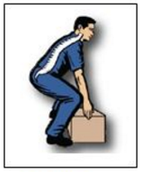
There is really no “right way” to lift. However, there are less demanding ways to lift. The key to working safely is to figure out how to lift in the least demanding way possible when you have to move materials or tools. Here are some guidelines to reduce your risk when lifting:

Keep It Close and Keep the Curves! The closer a load is kept to your power zone, the easier it is to keep the natural curves of your back. When the spine is in its natural curves, the vertebrae, discs, ligaments and muscles are in their strongest and most supportive position.
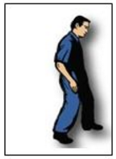
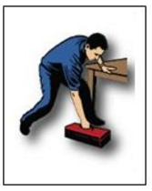
Staggered Stance: Lifting with the feet close together and in line with each other makes it more difficult for you to use your legs to help with the lift. Staggering your stance encourages the legs to become involved and reduces the demands on your back. Simply stepping toward a load (with a staggered stance) moves your center of gravity closer to the load and minimizes the demands of the lift. If you feel your weight shifting onto your forward leg, you have successfully transferred this weight demand from your back to your stronger legs.

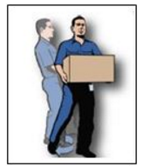
Build a Bridge: In most cases, the demands of any lift are determined by the position of the lifter’s upper body during the lift. Many people lift by bending over at the waist, leaving their upper body hanging like a “one-sided bridge”. This places all the demands of the lift onto the lower back. This load can be reduced by “building a bridge” to support the weight of the upper body. To do this, place an arm on your leg or a nearby stationary object. If you need both of your arms to manage the object your are lifting, step forward toward the load with one leg and create a “bridge” with your legs to reduce the workload on your back.

Feet First: Moving your feet first gets you closer to the load and reduces the amount you have to reach. The farther you reach, the more you have to lift your upper body as well as the load. Moving your feet first also helps reduce the risk of twisting while you lift.

Discussion Topic: Ask for volunteers to demonstrate the concepts of “Keep it Close and Keep the Curves”, “Staggered Stance”, “Build a Bridge”, and “Feet First”.

Prepare and Compensate:
Lifting and carrying loads can be hard work. Like athletes, workers can avoid injuries or discomfort by preparing the body for work. Muscles generate more force when warm and full of oxygen. Stretching and moving around prior to work helps pump blood into your muscles. Blood warms up muscles and brings in oxygen, allowing your muscles “to breathe”. This can be particularly effective at the beginning of the workday and after breaks.

Compensating for work demands simply means letting the body recover from work in an efficient manner. Performing periodic stretches can minimize accumulation of fatigue throughout the day. Stretches can “apologize” to the body for working it so hard.

Discussion
- Do you prepare and compensate before and after lifting and carrying heavy loads? Demonstrate some simple stretches that can help the employees prepare and compensate before and after a lift.

Use Mechanical Lifting Devices Whenever Possible
The best way to avoid a back injury is to reduce the number of lifts you have to do as much as possible. Hand trucks, pushcarts and forklifts are great engineering controls that reduce your exposure to lifting hazards. If you use a forklift, make sure you have training and are authorized to operate one.

Using hand trucks and pushcarts
- Push rather than pull. It is easier and safer to push than to pull. You can use your body weight to assist when pushing.
- Use powered carts when available.
- Keep close and lock your arms. Stay close to the load, try not to lean over and keep the curves of your back when pushing or pulling.
- Use both hands. Carts are easier to push and control using both hands.
- Use tie-downs, if necessary, to secure the load.

Discussion
- What devices are available to you in your workplace to reduce your exposure to lifting hazards? Are these devices enough or is there a need for additional devices?

Summary
- Evaluate the lifts you must do and determine if they can be safety done alone. If not, ask for help or get a mechanical lifting device.

- Follow these four guidelines to reduce the demands of the lifts you must complete:
  - Keep it close and keep the curves
  - Staggered stance
  - Build a bridge
  - Feet first
- When using carts, push rather than pull whenever possible. Use both hands and stay close to the load.

THIS PAGE INTENTIONALLY LEFT BLANK.

Hazard Communication and Awareness
IIPP Training Guide
501 Westwood Plaza, 4th Fl • Los Angeles, CA 90095 • Ph: 310-825-5689 • Fx: 310-825-7076 • www.ehs.ucla.edu
Effective dissemination of safety information is an integral part of your Injury and Illness Prevention Program. This document was created to facilitate worker safety training. Training must be completed before the use of any tool or piece of equipment, exposure to any hazardous condition, or when new hazards are identified.

Prepare the following items for this meeting:
- Training Documentation Form
- Your chemical inventory
- Printed copies of SDSs for 2 or 3 chemicals used in your department
- chemical container with label
- examples of PPE used to protect workers from chemicals (e.g., goggles, gloves, respirators)

Introduction
Many chemicals used in campus shops and labs are considered hazardous. All employees who work with these materials must understand the health hazards involved and how to protect themselves. Cal/OSHA regulations require employers to communicate the hazards of these chemicals to employees through the use of chemical labels and Safety Data Sheets (SDS).

Physical & Health Hazards
Hazardous chemicals pose a physical or health danger. Chemicals are classified as being physically hazardous when they are flammable, combustible, corrosive, or reactive. Chemicals presenting health hazards include carcinogens, toxics, irritants, and sensitizers. The health effects of chemicals can be either acute (short-term), or chronic (long-term). Acute effects can show up immediately or soon after the exposure. Chronic effects may take years to show up.

Chemical substances can be in the form of solids, liquids, dusts, vapors, gases, fibers, mists, and fumes. Solids and liquids are easier to recognize since they can be seen. Fumes, vapors and gases are usually invisible. The physical state of a substance has a lot to do with how it gets into your body and what harm it can cause.

Chemicals get into the body via three main routes of exposure: breathing (inhalation), skin (dermal) or eye contact, or swallowing (ingestion). Once chemicals have entered your body, some can move into your bloodstream and reach internal “target” organs, such as the lungs, liver, kidneys, or nervous system and damage them.

Discussion Topics:
- What chemicals or chemical products are used in your work area?
- Where do you store your chemicals or chemical products?
- How can you identify the chemicals used in your department?
- What are some physical and health hazards associated with common chemicals in your workplace?
- How can chemicals enter the body?

Safety Data Sheets/Labels and Warnings
Labels on chemical containers can provide basic safety information concerning the contents of that container. All containers must have labels. These labels are required to have the following 6 components (in no particular order);
- Product identifier
- Signal word
- Hazard statement
- Pictograms
- Precautionary statement
- Supplier information

Safety Data Sheets (SDSs) are data sheets that contain information about the health and safety properties of workplace chemical products. They are usually written by the supplier or manufacturer of the product. All employees must have access to SDSs for the chemicals they use.

An SDS is required to have certain information. The form is divided into 16 sections that provide different types of information about the chemical product. These sections are the same on every SDS. Under Cal/OSHA’s Hazard Communication standard, an SDS must contain the following information:

- Product identification
- Hazard identification
- Composition/Information on ingredients
- First-aid measures
- Fire-fighting measures
- Accidental release measures
- Handling and storage
- Exposure controls/personal protection
- Physical and chemical properties
- Stability and reactivity
- Toxicological information
- Ecological information
- Disposal considerations
- Transport information
- Regulatory information
- Other information

Exposure/Exposure Limits
When reading Safety Data Sheets (SDS), you will frequently encounter abbreviations such as PEL, TWA, STEL, and IDLH. These provide workers with important information on how long they can be exposed to a chemical before harm may occur, as follows:
- Permissible Exposure Limit (PEL): The maximum amount of a chemical a worker can be exposed to over an eight-hour period.
- Time-Weighted Average (TWA): The PEL is usually shown as a time-weighted average (TWA) to calculate exposure for an eight-hour workday and 40-hour work week.
- Short-term exposure limit (STEL): The amount of a chemical the worker should not be exposed to over a fifteen minute period.
- Immediately Dangerous to Life and Health (IDLH: Indicator that the chemical poses an immediate threat to your health.

Protection – Hierarchy of Controls
The three accepted strategies for controlling exposure to hazardous materials are engineering controls, administrative controls, and personal protective equipment (PPE). Engineering controls remove the hazard from the worker. An example of an engineering control is use of local exhaust ventilation or a fume hood. Administrative controls reduce worker exposure to hazardous materials. Examples include work practice changes, such as working with small quantities of chemicals or limiting exposure times. PPE is the least desirable control and should be used as last resort. The use of PPE does not reduce or eliminate the hazard at the source, but it does protect the worker from exposure. Sometimes, PPE is the only solution available.

Discussion Topics:
- What are the two primary methods of communicating chemical hazards to employees? Where are the SDSs kept in your facility?
- What type of information can be found on an SDS?
- What engineering and administrative controls are in place at your facility?

- What job tasks in your workplace involve chemical use that could expose an individual to the permissible exposure limit?
- What type of PPE is required to work with chemicals in your facility?

Summary
- Hazardous chemicals can pose health and/or physical hazards.
- Physical hazards refer to a chemical’s potential fire and/or explosive properties, and the chemical’s stability and reactivity to air, water, light, sparks, or heat.
- Health hazards affect the body in some negative way. Effects may be acute or chronic in nature.
- Chemicals get into the body through three main routes of exposure: breathing (inhalation), skin (dermal) or eye contact, or swallowing (ingestion).
- Information relating to chemicals and their hazards can be found on labels and SDSs provided by the manufacturer.
- SDSs are referenced in your IIPP Manual and made accessible for all employees to use.
- The permissible exposure limit (PEL) is the maximum amount of a chemical a worker can be exposed to over an eight-hour period.
- Workers can be protected by implementing engineering and administrative controls and PPE, or a combination of the three.
- Refer to the SDS for the required PPE if you work with or are in an area where chemicals are used.

Resources:

UCLA EH&S Hazard Communication Program Webpage – https://www.ehs.ucla.edu/ip/hazcom

UC SDS Website - https://ehs.ucop.edu/sds/#/

THIS PAGE INTENTIONALLY LEFT BLANK.

General Safety and Housekeeping
IIPP Training Guide
501 Westwood Plaza, 4th Fl • Los Angeles, CA 90095 • Ph: 310-825-5689 • Fx: 310-825-7076 • www.ehs.ucla.edu
Effective dissemination of safety information is an integral part of the Injury and Illness Prevention Program. This document was created to facilitate worker safety training. Training must be completed before the use of any tool or piece of equipment, exposure to any hazardous condition, or when new hazards are identified.

Prepare the following items for this meeting:
- Training Documentation Form
- Office Inspection Checklist or departmental equivalent form

Introduction
Good housekeeping is an effective way to eliminate potential hazards in the workplace. Good housekeeping practices involve material movement and storage throughout your entire workplace. It also includes a material flow plan to ensure minimal handling. Employee training is the key component that will ensure good housekeeping practices. Employees should be encouraged to report any hazards to their supervisor. Lastly, workplace inspections are essential tools used to find, recognize, and mitigate hazards that arise in the workplace.

Point of Discussion: Review the findings on the last inspection checklist with employees or take this time to conduct an overall inspection of your department and ask employees what items of housekeeping must be routinely checked.

Light Fixtures
All buildings need adequate lighting to make potential hazards visible and eliminate eye strain. Light fixtures with non-functioning light tubes need to be replaced. Storage areas that contain combustible materials should have explosion proof light fixtures installed. Lighting must be distributed evenly to eliminate shadows or dark spots in the workplace.

Point of Discussion: Are there any light fixtures that are non-functional or can you find an area in your workplace that could use more lighting?

Floors
Keeping floors dry and clear of trash and debris will greatly reduce slip, trip, and fall accidents. All spills should be cleaned up immediately. All sawdust, shavings, or clippings should be swept up or vacuumed once the cutting has ceased. Areas that cannot be cleaned continuously, such as entranceways, should have anti-slip flooring. Replace flooring that has been worn, ripped, or damaged, as this poses a tripping hazard. All floor openings must be guarded to prevent serious falls.

Point of Discussion: Are your floors kept free of trash and debris?

Chemical Spill Clean-up
Routine cleaning and maintenance of machines and equipment is a good way to eliminate the risk of spills. Drip pans and guards are another method of controlling spills where they might occur. If a chemical spill does occur, it is important to follow your workplace spill cleanup procedures. Part of the procedure should involve using the Safety Data Sheet for instruction on how to clean the spill and protect yourself from the chemical hazard. Absorbent material is useful for wiping up greasy, oily or other liquid spills. Used absorbents must be disposed of properly and safely. If the spill is greater than 1 liter or if you are experiencing symptoms of exposure, call 911 or the EH&S hotline (310-825-9797) to dispatch hazardous materials clean-up personnel.

Point of Discussion
- Do all employees know of the chemical spill clean-up procedures?
- Review chemical spill clean-up procedure if applicable.

Aisles and Stairways
Aisles and stairways must be kept clear of all objects that can cause trips and falls. Aisles must have 3 feet of clearance and any items that protrude into the aisle should be removed immediately. Warning signs and mirrors can prevent collisions by improving sight lines at blind corners. Stairways and aisles also must be kept clear of objects and can cause trips and falls and must have adequate lighting.

Point of Discussion: Are your aisles and stairways clear of all objects?

Maintenance
A good maintenance program provides for the inspection, upkeep and repair of tools, equipment, machines and processes. Routine maintenance of equipment and machinery must be conducted and recorded in your workplace maintenance log. Building maintenance should also be conducted. This involves painting and cleaning walls, maintaining windows, damaged doors, leaky plumbing, and broken tile or floor surfaces.

Point of Discussion: Are employees recording all routine maintenance and repairs in the maintenance log?

Waste Disposal
Disposal of trash, dust, clippings, and other material is essential to good housekeeping practices. Waste should not be allowed to build up on the floor as this poses a slip, trip, and fall hazard. Scrap containers should be placed near where the waste is produced, as this makes waste collection and disposal much easier. Waste receptacles should be clearly labeled with their contents and should be emptied out regularly.

Point of Discussion
- Discuss waste collection and disposal strategies.
- If you have hazardous waste in your facility, review the hazardous waste storage and disposal guidelines.

Material Storage
Safe storage practices are essential for good housekeeping. Items stored above chest level should have restraints in place to prevent them from falling. Workers should not be allowed to store items on top of personal lockers, cabinets, or machinery. Stored materials should allow at least 1½ feet of clearance under sprinkler heads and 2 feet of clearance beneath ceilings where no sprinkler system exists. Stored materials should not obstruct aisles, stairs, doorways, fire equipment, emergency shower or eyewash stations, first aid stations, machinery shut-offs or electrical panels. Designated storage areas should be clearly marked.

Point of Discussion: Are elevated storage requirements in effect in your workplace?

Fire Prevention and Storage of Flammables
Flammable, combustible, toxic and other hazardous materials should be kept in approved containers and stored in designated areas. Flammable material above ten gallons must be kept in a flammable storage cabinet. Flammable storage cabinets are required to be self-closing. Chemical storage inside flammables cabinets should be labeled, free of rust or corrosion, not stacked, and free of any cardboard. Oily or greasy rags should be placed in a metal container and disposed of as hazardous waste regularly.

Point of Discussion: If you have a flammable storage cabinet, do you take the time to dispose of any unwanted chemicals via the UCLA Surplus Chemical Redistribution Program?

Summary
- Importance of good housekeeping practices.
- Awareness of what good housekeeping involves.
- Knowledge of chemical spill clean-up procedures.
- Maintain clear egress.
- Hazardous waste guidelines.
- Storage of materials in the shop.
- Fire prevention.

THIS PAGE INTENTIONALLY LEFT BLANK.

Resources

This appendix contains information on EH&S safety tools and resources available to you:

- Guide to Services
- IIPP Fact Sheet
- Reporting Workplace Injuries Fact Sheet
- How to do an Office Inspection Fact Sheet
- List of Additional Fact Sheets

THIS PAGE INTENTIONALLY LEFT BLANK.
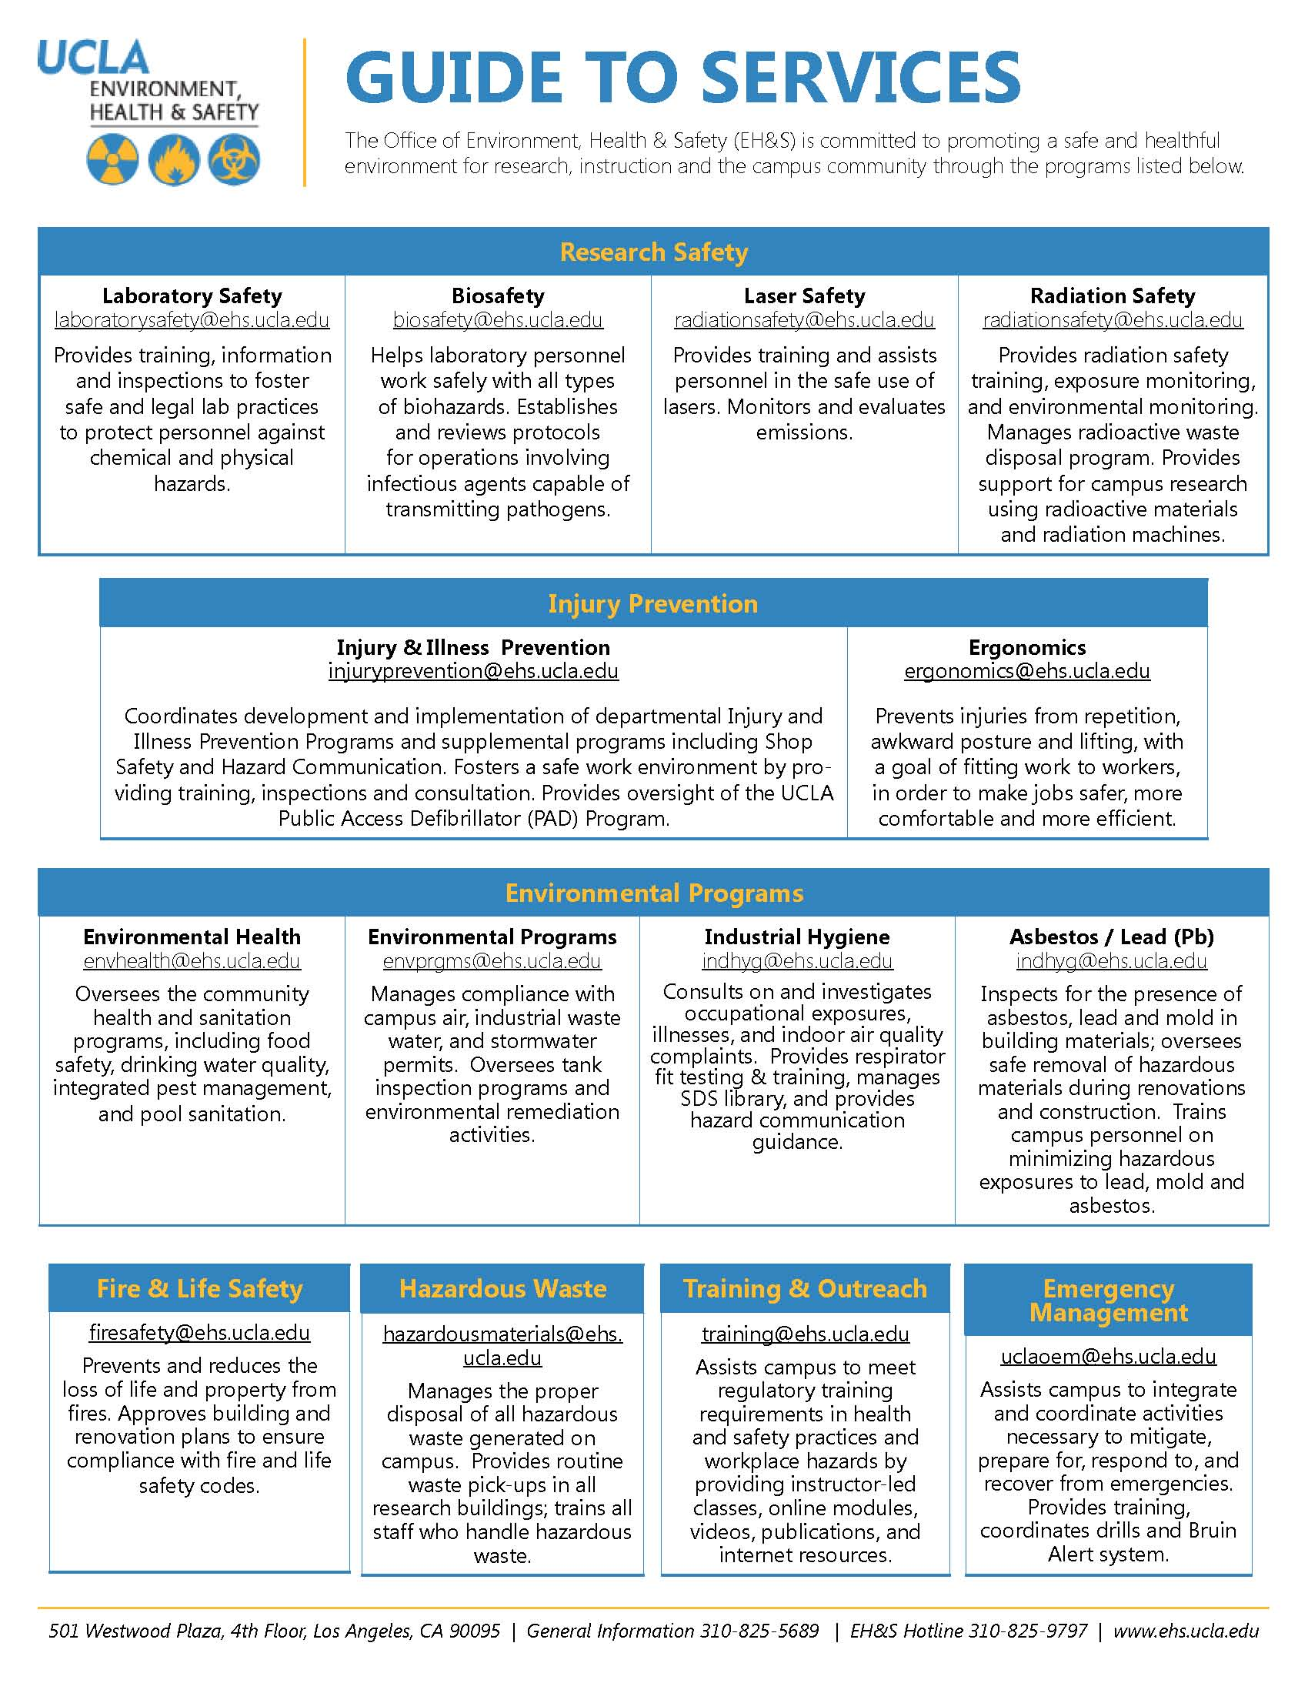

THIS PAGE INTENTIONALLY LEFT BLANK.
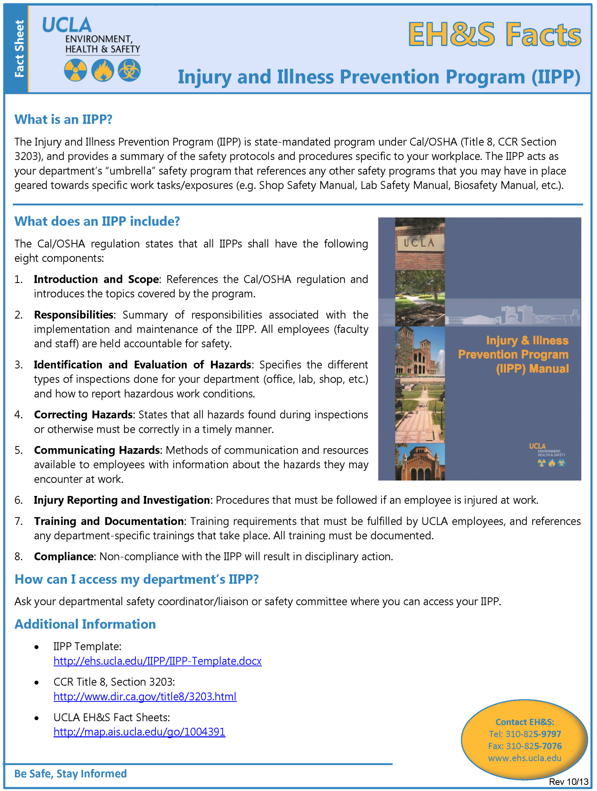

THIS PAGE INTENTIONALLY LEFT BLANK.
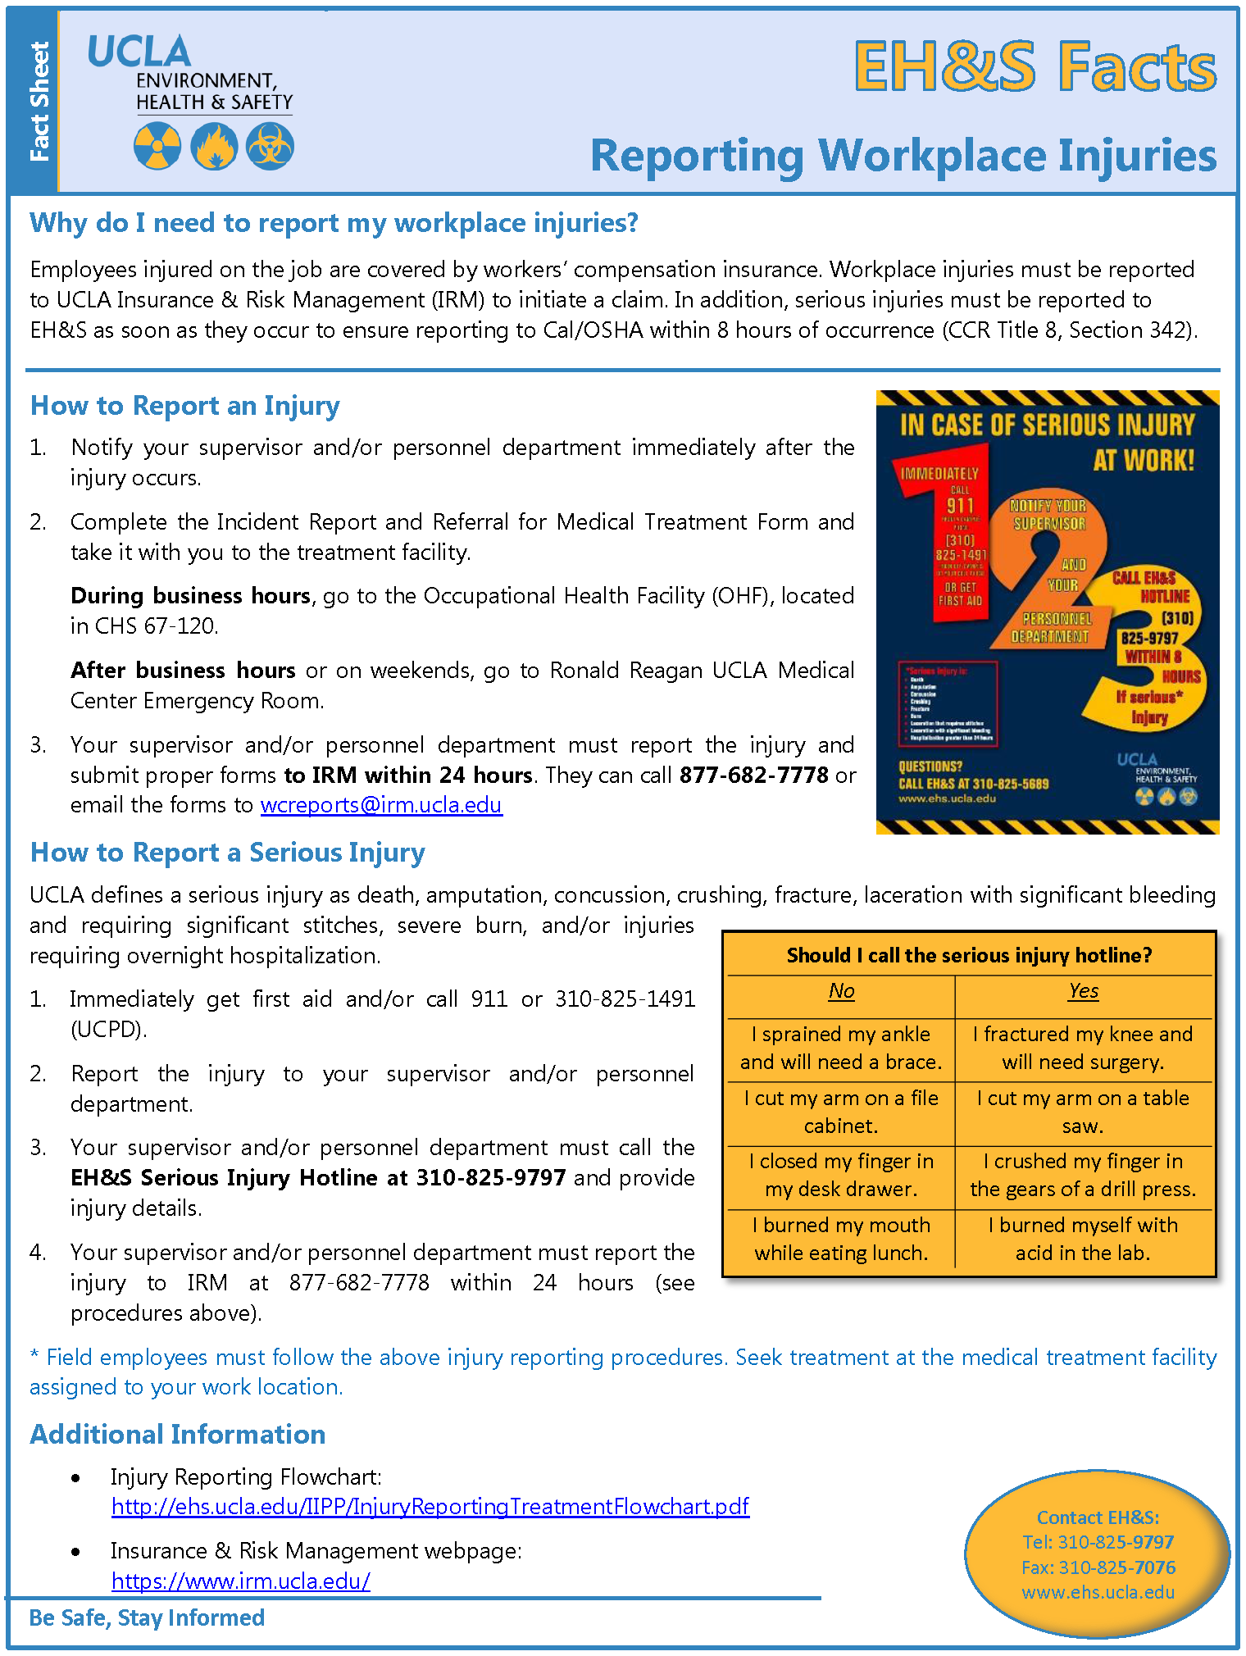
THIS PAGE INTENTIONALLY LEFT BLANK.
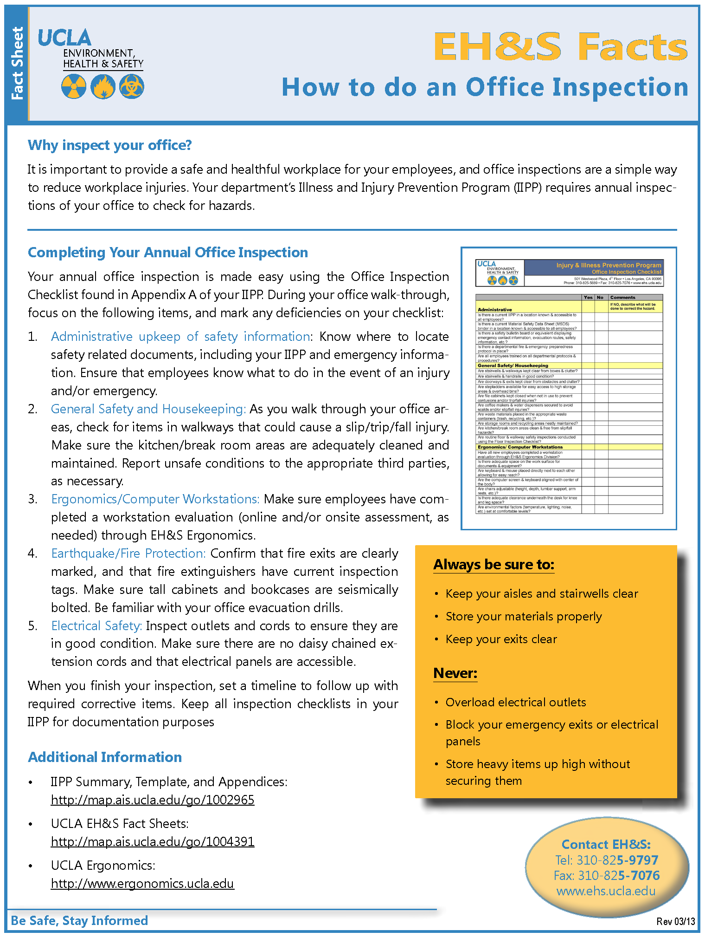
THIS PAGE INTENTIONALLY LEFT BLANK.
Additional EH&S Fact Sheets are available on https://www.ehs.ucla.edu/training/fact-sheets regarding the following topics:

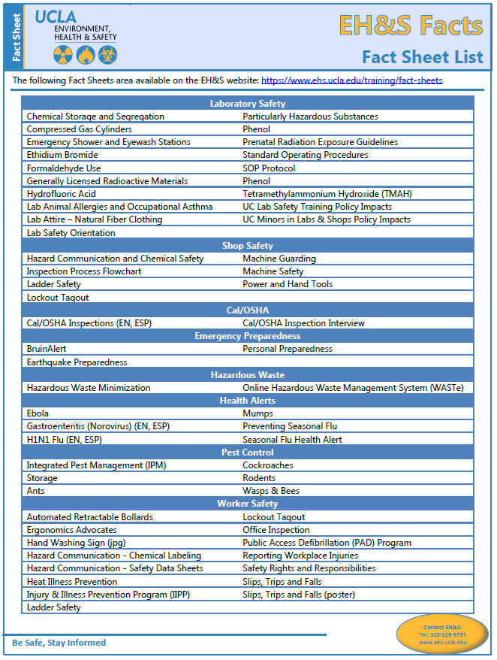
THIS PAGE INTENTIONALLY LEFT BLANK.

Departmental Training Records

This appendix houses the completed and sign-in sheets for the safety training sessions and inspection reports conducted for the department.

THIS PAGE INTENTIONALLY LEFT BLANK.

Injury & Illness Prevention Program
Training Documentation Form
501 Westwood Plaza, 4th Fl • Los Angeles, CA 90095 • Ph: 310-825-5689 • Fx: 310-825-7076 • www.ehs.ucla.edu

Document departmental safety training sessions and place a copy with your departmental training records. Attach a copy of the training presentation outline or summary.

Topic: _________________________________ Facilitator: _________________________________

Objective(s): ________________________________________________________________________

Location: ________________________________ Date: _____________ Duration: ________________

Name | Signature | UCLA ID#
THIS PAGE INTENTIONALLY LEFT BLANK.

